Biopsychology Learning Table 1: The Nervous System
The nervous system is a specialised network of cells and our primary internal communication system. It’s two main jobs are:
1) To collect, process and respond to information in the environment.
2) To coordinate the working of different organs and cells in the body. It is divided into two subsystems:
Central Nervous System (CNS)  Controls behaviour and regulates physiological processes. |  | Peripheral Nervous System (PNS)  All the nerves outside the CNS make up the PNS. Relays nerve impulses from the CNS to the rest of the body and back again.
The Brain | The Spinal Cord | The Somatic Nervous System | The Autonomic Nervous System
- Divided into four main areas:  - Cerebrum: largest part of the brain responsible for many functions such as speed production or processing visual images.  - Cerebellum: Controls motor skills and balance.  - Diencephalon: contains the thalamus which acts as a relay station for nerve impulses coming from the senses and the hypothalamus which is responsible for regulation of body temperature amongst other things. The hypothalamus also causes hormones to be released from the pituitary gland.  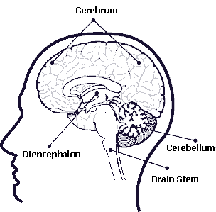  - Brain Stem: regulates functions essential for life such as heart beat, swallowing and breathing. | - Relays information between the brain and the rest of the body.  - Is connected to different parts of the body by spinal nerves which connect to specific muscles and glands.  - Contains circuits of nerves that perform simple reflexes (without direct involvement of the brain) such as pulling your hand away from a hot plate.  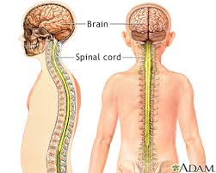 | - Made up of nerves emerging directly from the brain and nerve emerging directly from the spinal cord.  - Contains both sensory and motor neurons.  - Sensory neurons relay messages to the CNS  - Motor Neurons relay messages from the CNS.  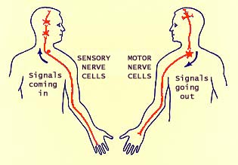 | - Regulates involuntary actions such as intestines digesting food.  - Divided into two parts, sympathetic and parasympathetic branches. They work on the same organs but have opposite effects.  - Sympathetic Nervous System (SNS) is responsible for fight or flight response. (See learning table 4).  - Parasympathetic Nervous System (PNS) is responsible for relaxing the body after a fight or flight response.  