Learning Table 5: Real Life Applications
ADVERTISING
- Subliminal Advertising
Research into perception can be useful to people working in the world of advertising. If audiences are going to buy a product, they have to perceive it as something they want or need in the first place. Research has shown that advertisers can influence potential customers’ perception of a product in terms of how they present it. A subliminal message is a brief sound or image message that it directed at us without us being aware of it, that is, with less than 50% chance of us spotting it. The problem is that a hidden message can actually make us do something because our unconscious has heard or seen it all and gets on with it!
1950’s America  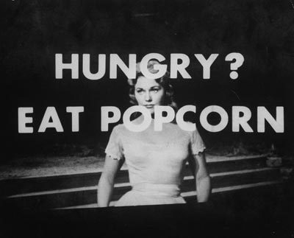  In America in the late 1950s, filmgoers watching the film Picnic were reported as having bought 50% more popcorn and 18% more Coca-Cola when the words ‘eat popcorn’ and ‘drink Coca-Cola’ were projected on the screen subliminally for 1/3,000th of a second, which is well below the level of perception for seeing visual information or pictures, i.e. you wouldn’t be conscious of it. A second trial, with the words ‘Ice Cream’, was claimed to have led to a rise in sales of ice cream. | Supermarkets  In a superstore, research was done into the background music being played and it noted the effect the music had on customers shopping habits. When it was French music, the amount of French wine bought rose substantially. When the music changed to Italian, more Italian wine was bought.
- Techniques Used by Advertisers
Advertising for the brain  Research has shown that different parts of the brain are responsible for processing different types of information. Research has also shown that information entering through the left eye goes to the right side of the brain and vice-versa. Some Psychologists argue that the emotional part of a TV advert should be the on the left hand side of the screen so it can be interpreted by the right hand side of the brain. Any messages of words should be on the right side of the screen, to be interpreted by the left side of the brain which deals with language. | Use of context in the advertising  Perception of an object can be affected by the context it is presented in; for example, in adverts. The same pair of jeans may look sexier when modelled by a young, glamorous supermodel than when modelled by an older, dowdy woman. The same meat pie may look bigger and more appetising on a small plate with a few vegetables than on a huge plate piled with potatoes. The same car may appeal more to a female audience if driven by a woman than if driven by a man.
NOTE: You do not need to know both subliminal advertising & techniques used by advertisers. Just learn one for the exam!

