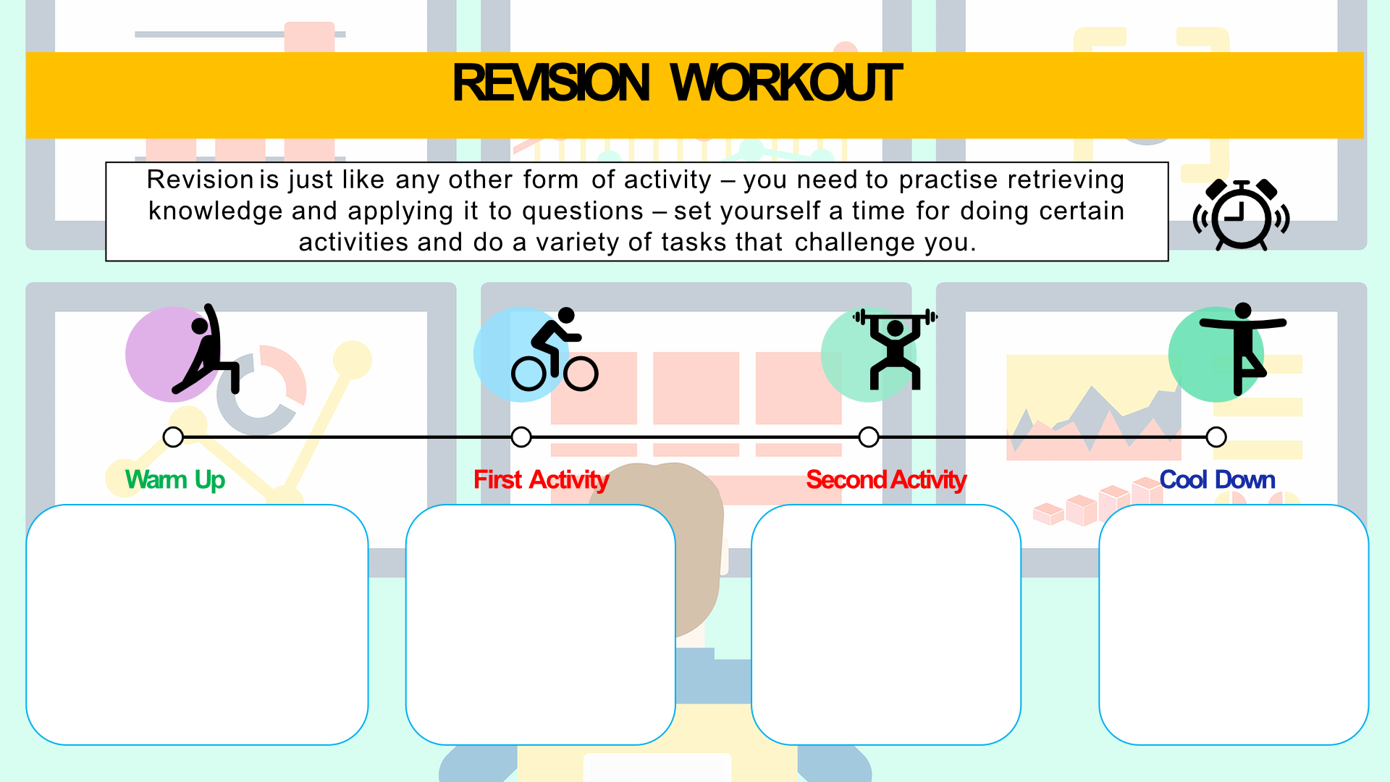

Knowledge and Understanding Application Analysis Evaluation

