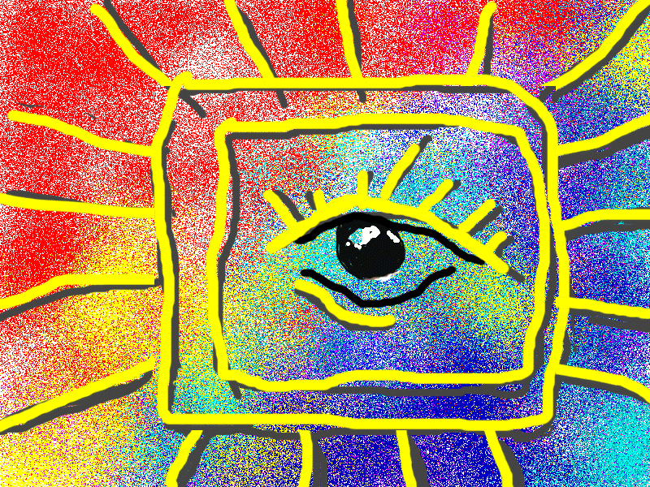
Introduction to Sociology

How much do you know about your society?

- How many people live in the UK?
  - 12, 000,000
  - 35,000,000
  - 61,000,000
  - 93,000,000

- Of the total amount of people who live in the UK, how many come from an ‘ethnic minority’ background (ie Afro-Caribbean, Asian, Eastern European etc…)
  - 15,000,000
  - 50,000,000
  - 12,000
  - 4, 500,000

- From the list of ethnic groups below, rank order which groups you think have the highest male smoking rates.
  - Black Caribbean
  - White English
  - Bangladeshi
  - Indian
  - Pakistani
  - White Irish

- What percentage of marriages in the UK are inter-ethnic?
  - 2%
  - 10%
  - 22%

- What percentage of the UK population has access to a digital television service?
  - 15%
  - 25%
  - 45%
  - 65%

- What was the life expectancy (how long you can expect to live) for men and women in the UK in 1901?
  - 45 years old
  - 49 years old
  - 64 years old
  - 68 years old
  - 72 years old

- What is the current life expectancy for men and women in the UK?
  - 57 years old
  - 62 Years old
  - 72 years old
  - 76 years old
  - 81 years old

- Below are three reasons why life expectancy has increased in the UK. since 1901 - Rank them in order of impact.
  - Health and safety rules introduced in the work place.
  - Improvements in medical science and the development of modern medicine.
  - Access to clean drinking water.

Sociology – see life differently
The strange tale of Shirbit culture

The Shirbit culture believes that the human body is ugly and that its natural tendency is to feebleness and disease. The Shirbits therefore indulge in rituals and ceremonies designed to avoid this, and consequently every Shirbit family has a shrine devoted to the body. The rituals associated with the shrine are private and secret. Adults never discuss the rituals and children are only told enough for them to be successfully initiated into the basics of their culture.
The focal point of the shrine is a box built into the wall in which are kept charms and magical potions for the face and body. These are obtained from the medicine men who write down the ingredients in an ancient and secret language which is only understood by the herbalist who prepares the potion.
These potions are kept in the charm box for many years. Beneath the charm box is a small font. Every day, twice a day, every member of the Shirbit family enters the shrine room in succession and bows his/her head before the charm box, mingles different sorts of holy water in the font and performs a brief rite of ablution.
The shirbit have an almost pathological horror of and fascination with the mouth; the condition of which is believed to have a supernatural influence on all social relationships. Were it not for the rituals of the mouth, they believe their teeth would fall out, their friends would desert them and their lovers would reject them.
Finally, men and women indulge in barbaric acts of self-mutilation. Men engage in a daily body ritual of scraping and lacerating their faces with a sharp instrument, while the women bake their heads in a small oven once a month.
(Collins Sociology A/s for AQA pg 2/3)

Once you have read about the Shirbit culture answer the following:

- Where in the world do you think the Shirbits can be found (country or continent)?

- What aspects of Shirbit culture seem strange to you?

