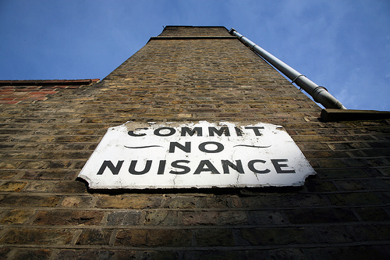

|  |
| --- |
| Unit 1: Functionalist theories |
| A guide to the ruins |
|  |

A guide to the symbols

|  |  |
| --- | --- |
| This symbol | Means you will be doing this sort of activity |
| MC900304333[1] | A ‘think – pair –share’ type activity |
| [John Greenaway jones](https://twitter.com/roryandiz) | A tweet – limited words activity |
| MC900293480[1] | A peer-teaching/explaining activity |
|  | A jigsaw/marketplace-type activity |
| MC900359715[1] | An online/internet-based activity |
|  | An activity using drawing or posters |
| MC900196546[1] | An unavoidable listening to me opportunity (used sparingly, promise). |

|  |  |
| --- | --- |
| This symbol | Means you will be doing this sort of activity |
| MC900187587[1] | Some thinking – it’s good for you ! |
| MC900056352[1] | A choice from a range of things |
| MC900060322[1] | Stuff to do at home or in your frees |
| southpark-1205EekAPenis2-cartman_1207668702 | Giving a presentation |
| MC900071185[1] | Peer-assessment and review |
| MC900056929[1] | Finding stuff out |
| [See full size image](http://i375.photobucket.com/albums/oo193/chaosnonstop/Chaos.j) | This seemed like a good idea at the time... |

Notes

**Durkheim and Functionalism**

**Parsons and Functionalism**

**Merton and Functionalism**

**Evaluation of Functionalism**

Social facts

Collective conscience

Organic analogy

Value consensus

Integration of individuals

System needs (GAIL)

Types of society

Critique of Parsons

Manifest and latent functions

Teleology

Conflict perspectives

Action perspectives

Activity 1: Introducing functionalist theory\_\_\_\_\_\_\_\_\_\_\_\_\_\_\_\_\_

Two crucial questions

A functionalist analysis of any part of society is essentially answering two questions:

* What functions does it perform ?
* How is this part of society related to other bits ?

MC900187587[1]Task 1 : What functions does it perform ?

Complete the diagram below to show the functions you think the main institutions of society might fulfil.

**Society**

MC900187587[1]Task 2: How this part of society is related to the other bits

This exercise is designed to encourage you to find some of your own answers to this second question. Fill in the following table and use those already completed to guide you.

**Functional relationships between the family and other social institutions**

|  |  |  |
| --- | --- | --- |
| Institution | Influence *from* the family | Influence *on* the family |
| **Education** | The family socialises the child before school and provides support during school years. |  |
| **Religion** |  | Religion sets down rules for marriage and family relationships. It provides a sense of belonging to a family. |
| **Politics** | The family provides new socialised citizens/voters and gives young people their first political attitudes. |  |
| **Law** |  | Laws determines boundaries with regard to how family members can treat each other – e.g. the age at which children can be left alone etc. |
| **Work** |  | Supplies jobs and income to support family members. |

Activity 2: Durkheim and functionalism\_\_\_\_\_\_\_\_\_\_\_\_\_\_\_\_\_\_\_\_

[John Greenaway jones](https://twitter.com/roryandiz) Task 1: The collective conscience and social facts

Look at Box 4.1 on p.221 of the Theory IPC. Read this very carefully and :

1. briefly explain in your own words what Durkheim means by the collective conscience
2. in your own words explain the relationship between the division of labour and the collective conscience
3. explain what Durkheim means by ‘social facts’
4. use your answers to annotate the relevant section of the summary map on page 5 of this study guide.

Activity 2: Parsons and functionalism\_\_\_\_\_\_\_\_\_\_\_\_\_\_\_\_\_\_\_\_\_\_

The co-operative guide to Parsons

This is a scrambled groups exercise to look at the various parts of Parsons’ general functionalist theory.

You will be placed into groups of 5 and assigned one each of the following areas to briefly research:

1. the organic analogy
2. Value consensus
3. the integration of individuals
4. the social systems needs
5. different types of society

You will then:

* peer teach each other your findings with ‘pens down’
* use your notes from this activity to annotate the relevant section on the summary map on page 5 of this study guide

Activity 3: Merton’s internal critique of functionalism\_\_\_\_\_\_\_

The attack on Parsons’ assumptions

The big idea behind Merton’s attack is that Parsons assumes that society is always a smooth-running and well-integrated system. This ain’t always the case.

We can break this down into the three key assumptions below. Using page 223 of the Theory IPC. Your task is to illustrate these criticisms by drawing them - stick people summaries !

Indispensibility

Functional unity

Universal functionalism

Don’t forget to annotate your summary mind map !

Activity 4: Other criticisms of functionalism\_\_\_\_\_\_\_\_\_\_\_\_\_\_\_\_

Look at page 224 of the Theory IPC. Do a ‘writing on the reading’ analysis of the four external critiques of functionalism. Then, complete the chunking exercise below:

|  |  |  |
| --- | --- | --- |
| 1. Functionalists seem unable to explain social change and conflict. | 2. Functionalism provides a very over-socialised view of the individual. | 3. Functionalism reifies society – in other words it treats it as a thing over and above the individual rather than something being a collection of constructs used by individuals to make sense of the world around them. |
| 4. Functionalismis merely another ‘meta-narrative’ trying to produce an entire theory to explain how the world works. | 5. Popper would accuse functionalists of being unscientific because it cannot be falsified by testing. | 6. Meta-narratives such as functionalism cannot explain how society works because today society is becoming increasingly fragmented. |
| 7. Functionalism is a conservative ideology that seeks to justify the existing social order as inevitable and desirable. | 8. Functionalist claim things exist because they have a function. However, critics argue that this reasoning is wrong. Things exist because they have a cause. | 9. Functionalist claim that deviance is both functional (by reinforcing norms and values)) and dysfunctional (society’s needs can only be meet if people conform) at the same time. Therefore it cannot be falsified. Therefore functionalism is not scientific. |

Which of the above statements are features of:

* logical criticisms of functionalism
* Conflict perspective criticisms
* Action perspective criticisms
* Postmodernist criticisms

Don’t forget to add these to your summary map on page 5.

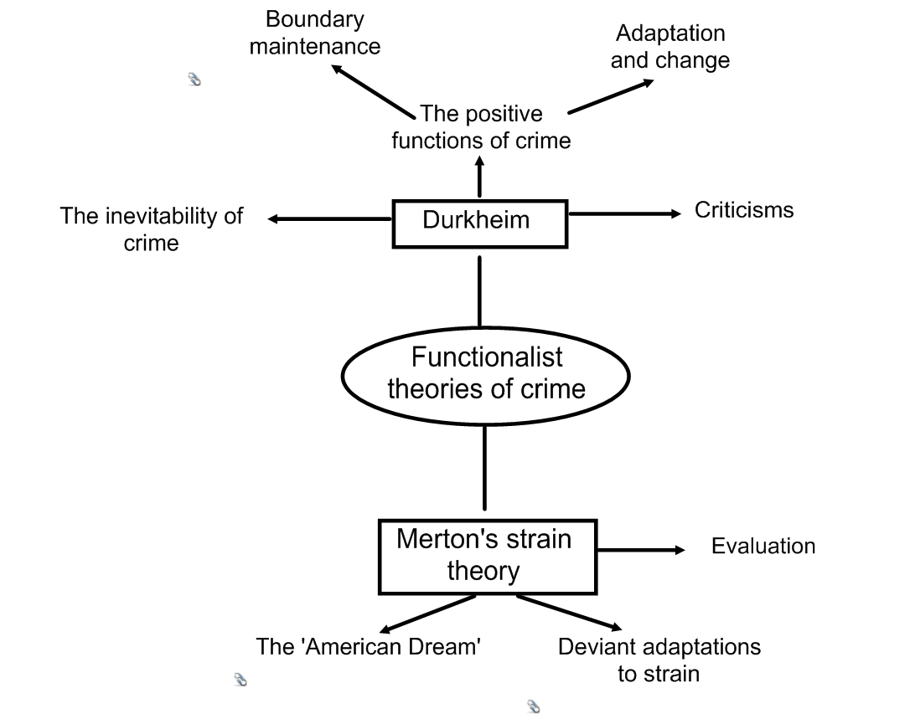

Activity 5: Durkheim’s functionalist theory of crime\_\_\_\_\_\_\_\_

MC900304333[1] Task 1:

Complete the following starter activity:

On your own, spend five minutes thinking about the following questions:

1. For functionalists, why is value consensus so important ?
2. Why might functionalists such as Durkheim argue that crime and deviance is inevitable in society ?
3. Why might Durkheim say that crime and deviance can have a positive role or function in society ?

*Use this space for ideas*

[John Greenaway jones](https://twitter.com/roryandiz) Task 2: The inevitability of crime

Read through this section on page 73 of the Crime and Deviance IPC.

Highlight the key points as you go. When you’ve finished, compose a Tweet summarising Durkheim’s ideas. You have 140 characters only to use !

*Practice attempts*

[John Greenaway jones](https://twitter.com/roryandiz) What’s happening ? 140

*Final version*

MC900293480[1] Task 3: The positive functions of crime

In pairs, look at the section on the positive functions of crime on pages 73-74 of the Crime and Deviance IPC. One of you look at boundary maintenance and the other look at adaptation and change.

Each of you should summarise your section in no more than 3 key points, and then peer teach your points to each other.

*Notes*

Task 4: Boundary maintenance

Look at the diagrams below and explain what is happening in them.

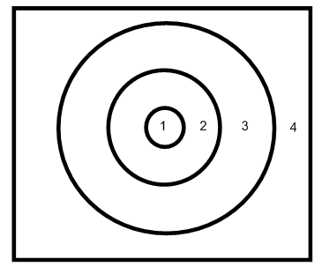

1. Core values

2. Permitted action

3. Deviant action

4. Illegal action

Expansion of permitted acts Contraction of permitted acts

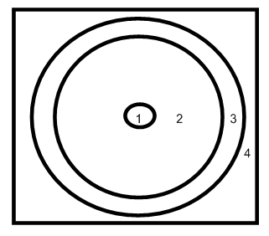

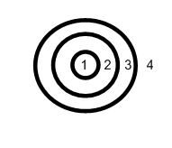

Changes in:

1. The interpretation of the law by the courts

2. Public opinion

3. The law itself

All of these can lead to changes in the relationship between core values, deviant acts and illegal acts.

MC900187587[1]Task 5: Adaption and change

A further function of crime and deviance for Durkheim is that of promoting social change.

Try to think of at least two ways in which acts of deviance have allowed society to change.

For example you may wish to think of individuals or acts which were considered deviant in the past, but might now be regarded as ‘anticipating future morality’.

*Use this space for ideas*

 Task 6: Putting all this together

Go back to page 11 of this study guide and have a go at annotating the part of the overview diagram which covers Durkheim. Try to do most of this from memory.

Activity 6: Merton’s Strain Theory\_\_\_\_\_\_\_\_\_\_\_\_\_\_\_\_\_\_\_\_\_\_\_\_

 Task 1: The causes of deviance

Read pages 74-75 in the Crime and Deviance IPC down to the heading ‘Deviant adaptations to strain’. Using the ideas from this section, draw a diagram showing how Merton explains why some people commit deviant acts.

MC900187587[1] Task 2: Deviant adaptations to strain

Firstly, read the section on deviant adaptations to strain on p.75 of the Crime and Deviance IPC by doing a writing on the reading. Then decide which of the statements on page13 of this study guide best describe the adaptations in the grid below:

|  |  |
| --- | --- |
| **Adaptation** | **Description** |
| Conformity |  |
| Innovation |  |
| Ritualism |  |
| Retreatism |  |
| Rebellion |  |

|  |  |
| --- | --- |
| **Adaptation** | **Description** |
|  | This response means giving up or losing sight of both means and goals by opting out or dropping out of conventional society, for example living a ‘down and out’ life of oblivion through drink or drug abuse. Such behaviour can occur in any social class. |
|  | This is the response of the majority, the stereotypical ‘law-abiding citizen’ who uses conventional means such as a job to pursue the approved goals of success,whcih may never be reached. |
|  | Both goals and means are rejected, but alternatives are constructed. An example is the political revolutionary who rejects conventionalsociety and strives to create a new society by means of violent revolution. |
|  | Socially acceptable means, such as a job, are rejected, but the goals of success are still pursued. So a person might resort to crime to be come rich. Another way could be gambling, or trying your luck at the lottery. |
|  | This is where the means to the goal;s are accepted and conformed to, but the person losses sight of the goals. The person therefore goes through the motions but has no real interest in the outcome. An example might be a student who spends a lot of time on the presentation of an assignment, but does not answer the question. |

 Task 3: Putting this all together

Go back to page 12 of this study guide and have a go at annotating the part of the overview diagram which covers Merton. Try to do most of this from memory.

MC900187587[1] Task 4: An evaluation of strain theory

Good evaluation requires you not only to be able to identify strengths and weaknesses of a theory, method, study etc, but also to be able to explain and expand on these.

Listed below are a number of partly completed statements relating to the strengths and weaknesses of strain theory.

Your task is to:

1. complete the statements by selecting the appropriate finishing clauses from those provided
2. write a three or four lined commentary explaining each statement.

|  |  |  |  |
| --- | --- | --- | --- |
| **Strengths** | **Matching strengths clauses** | **Weaknesses** | **Matching weaknesses clauses** |
| 1. The theory clearly focuses……. | In deviant behaviour to the ideologies of societies | 1. It offers a liberal rather than radical critique of US society…… | And tends to accept that the structure of the US is legitimate itself. |
| 2. It offers a useful typology…… | On the social when explaining crime and delinquency | 2. It assumes that every American…. | By low aspirations rather than frustrated ambition. |
| 3. The approach links the increase…… | Attempting to improve opportunities for the disadvantaged | 3. Delinquent subcultures may also be characterised…. | Opts for a particular mode of adaptation. |
| 4. Strain theory has led to many programmes…… | For different types of reaction to anomie | 4. It is not totally clear why one individual….. | Is socialised into the American Dream. |