Crime & Deviance

What are we going to do today?
- Understand the meaning of crime & deviance.
- Identify why some crimes aren’t deviant acts.
- Understand how crime & deviance are related to time & place.
- Evaluate the ways in which deviancy can be created.

As you watch the images on the screen decide if the actions are acceptable behaviour, unacceptable behaviour, a crime or both.
Tick the appropriate boxes below.

Action/Behaviour |  | Unacceptable? | Acceptable? | Crime?
No.1 | 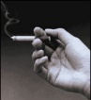
No.2 | 
No.3 | 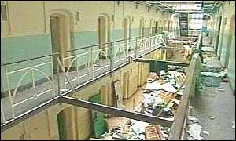
No.4 | 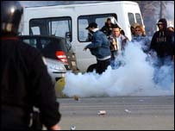
No.5 | 
No.6 | 
No.7
No.8

A crime is__________________________________________________________________
__________________________________________________________________________
A deviant act is______________________________________________________________
____________________________________________________________________________________________________________________________________________________
Why are some crimes not considered deviant? Think about the lady who was barred from Sainsbury’s for stealing Pick n Mix.________________________________________________
__________________________________________________________________________________________________________________________________________________________________________________________________________________________________________________________________________________________________________________________________________________________________________________
How are crime & deviance related to time & place? Can you think of any actions that are more or less deviant depending on when & where the actions take place?__________________________
__________________________________________________________________________________________________________________________________________________________________________________________________________________________________________________________________________________________________________________________________________________________________________________
Making an action illegal doesn’t always make the action deviant. So, how do actions become deviant?
Smoking has become a deviant act because…_________________________________________
__________________________________________________________________________________________________________________________________________________________________________________________________________________________________________________________________________________________________________________________________________________________________________________

Homework Task:
Although stealing Pick n Mix is a crime Sainsbury’s feel that it is not considered deviant by most shoppers. They have employed you to design the advert that will be displayed around all of their stores. They hope to make stealing Pick n Mix a deviant act that people feel is wrong.
Your Homework is to design that advert. Think about…
How will you put people off from stealing Pick n Mix?
How will you make it ‘not the done thing?’

