ULTIMATE SOCIOLOGY QUIZ

Round 1: Key Terms
Round 2: Who Am I?
Round 3: Picture Round - (No Joker allowed for Round 3)
Round 4: Pot Luck

Which round will you play you Joker in?
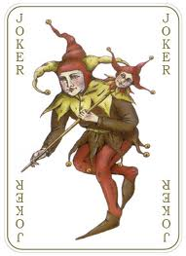
(Joker = double points)

TEAM NAME

TEAM

Round 1: Key Terms

1. | Term used by Durkheim to describe the breakdown of social expectations and behaviour |  | Anomie
2 | The process by which an area moves from being predominately law-abiding, to predominately accepting anti-social behaviour |  | Tipping
3 | Term used by Merton and other functionalists to describe problem between socially accepted goals and the socially approved means of obtaining the desired goals |  | Strain Theory
4 | Crimes committed by companies against employees or the public |  | Corporate Crime
5 | Idea that young males go right to the margins of acceptable behaviour and ‘flirt’ with danger |  | Edgework
6 | An outrage stirred up by the media about a particular issue or group |  | Moral Panic
7 | Activities which break the law of the land and are subject to official punishment |  | Crime
8 | A phrase adopted by Jock Young, describing the situation whereby a sociologist participate with the group and fully takes on board their views, attitudes and lifestyles to give him/her a deep understanding |  | ‘Going Native’
9 | An annual vicitmisation survey carried out by the Home Office |  | British Crime Survey
10 | Statistics referring to how many crimes are committed, and by which groups of people |  | Offending rates
11 | A perspective developed from Marxism, which argues that it is better to work within capitalism to understand the reasons for criminal behaviour and to attempt to improve people’s lives, e.g. reduce material deprivation |  | Left Realism
12 | Refers to those who are pushed to the edge of society in cultural, status or economic terms |  | Marginalized
13 | According to Cohen, this occurs when young men feel they are looked down upon by society |  | Status Frustration
14 | Jock Young’s study investigated this concept. It looked at the actions of the police and media in response to perceived defiant behaviour and how it lead to an increase in deviancy levels |  | Deviancy Amplification
15 | A distinctive set of values that provides an alternative to those of mainstream culture. These distinctive values will be shared by a small homogenous group. |  | Subculture
TEAM

Round 1: Key Terms

1. | Term used by Durkheim to describe the breakdown of social expectations and behaviour
2 | The process by which an area moves from being predominately law-abiding, to predominately accepting anti-social behaviour
3 | Term used by Merton and other functionalists to describe problem between socially accepted goals and the socially approved means of obtaining the desired goals
4 | Crimes committed by companies against employees or the public
5 | Idea that young males go right to the margins of acceptable behaviour and ‘flirt’ with danger
6 | An outrage stirred up by the media about a particular issue or group
7 | Activities which break the law of the land and are subject to official punishment
8 | A phrase adopted by Jock Young, describing the situation whereby a sociologist participate with the group and fully takes on board their views, attitudes and lifestyles to give him/her a deep understanding
9 | An annual vicitmisation survey carried out by the Home Office
10 | Statistics referring to how many crimes are committed, and by which groups of people
11 | A perspective developed from Marxism, which argues that it is better to work within capitalism to understand the reasons for criminal behaviour and to attempt to improve people’s lives, e.g. reduce material deprivation
12 | Refers to those who are pushed to the edge of society in cultural, status or economic terms
13 | According to Cohen, this occurs when young men feel they are looked down upon by society
14 | Jock Young’s study investigated this concept. It looked at the actions of the police and media in response to perceived defiant behaviour and how it lead to an increase in deviancy levels
15 | A distinctive set of values that provides an alternative to those of mainstream culture. These distinctive values will be shared by a small homogenous group.

TEAM

Round 2: Who Am I?

1 | This sociologist studied British sub-cultural groups, looking specifically at a Middle and Working Class sub-cultural group (The Saints & Roughnecks). Finding that the elaborate code, more positive labelling and parental support helped lead to different outcomes for the MC & WC group members | William Chambliss
2 | I set up an enquiry to look at the racist murder of the black youth Stephen Lawrence and found that the police were characterized by institutional racism | William Macpherson  (Macpherson Inquiry)
3 | We divided cities into Concentric Zones and looked at the impact of waves of immigration (and rapid change) and the impact it had on cities as they moved into the cheapest and least desirable zones (Zone 2). | Shaw & McKay
4 | I investigated the idea of ‘labelling’ and particularly explored the idea that a person may have several labels, but might identify a ‘Master Label’ which dominates a person’s self image | Howard Becker
5 | I decided that there were social laws, in particular I studied suicide and found that the causes related to social integration and social control | Durkheim
6 | This sociologist built upon Merton’s work, and found that working class boys had middle class values but often lacked the means to achieve them (status frustration). This often lead to a sense of failure, this was often very obvious in school and in an attempt to gain status they would often behave disruptively | Albert Cohen
7 | We came up with the ‘Broken Windows’ theory suggesting that crime flourishes in communities where social control has already broken down | Wilson & Kelling
8 | This sociologist argues that crime can have positive elements, such as reaffirming boundaries, helping us to realise that values/laws need to be changed and creating social cohesion/unity over criminal acts | Durkheim
9 | I studied the role of women in crime, finding that women were more supervised and constrained throughout life. They didn’t have the same opportunities as men to commit crimes. | Heidensohn
10 | This Left Realist felt that crime could be attributed to 3 elements, relative deprivation, marginalization & subculture | Jock Young
11 | I studied Mods and Rockers in the 1970s and looked at how the media built up anxiety about these two groups and created ‘Moral Panics’ | Stan Cohen
12 | We looked at the impact of local authority housing policies on estates, causing an anti-social minority to grow and eventually drive away law abiding families, the estate becomes ‘Tipped’ and regarded as a problem | Baldwin & Bottoms
13 | I also looked at suicide and found the causes were due to transforming one’s self for others, transforming the self, gaining revenge, achieving sympathy | Douglas
14 | I developed the theory that the socially accepted middle class goals where often not easily achievable to the working classes. This resulted in strain and led to deviance. | Robert Merton
15 | This sociologists looked at the role of the coroner when investigating potential suicides. He noted that the coroner had to use primary and secondary clues to draw a conclusion, e.g. existence of a suicide note, mode of death, location and circumstances, and the life history and mental condition of the person | Atkinson

TEAM

Round 2: Who Am I?

1 | This sociologist studied British sub-cultural groups, looking specifically at a Middle and Working Class sub-cultural group (The Saints & Roughnecks). Finding that the elaborate code, more positive labelling and parental support helped lead to different outcomes for the MC & WC group members
2 | I set up an enquiry to look at the racist murder of the black youth Stephen Lawrence and found that the police were characterized by institutional racism
3 | We divided cities into Concentric Zones and looked at the impact of waves of immigration (and rapid change) and the impact it had on cities as they moved into the cheapest and least desirable zones (Zone 2).
4 | I investigated the idea of ‘labelling’ and particularly explored the idea that a person may have several labels, but might identify a ‘Master Label’ which dominates a person’s self image
5 | I decided that there were social laws, in particular I studied suicide and found that the causes related to social integration and social control
6 | This sociologist built upon Merton’s work, and found that working class boys had middle class values but often lacked the means to achieve them (status frustration). This often lead to a sense of failure, this was often very obvious in school and in an attempt to gain status they would often behave disruptively
7 | We came up with the ‘Broken Windows’ theory suggesting that crime flourishes in communities where social control has already broken down
8 | This sociologist argues that crime can have positive elements, such as reaffirming boundaries, helping us to realise that values/laws need to be changed and creating social cohesion/unity over criminal acts
9 | I studied the role of women in crime, finding that women were more supervised and constrained throughout life. They didn’t have the same opportunities as men to commit crimes.
10 | This Left Realist felt that crime could be attributed to 3 elements, relative deprivation, marginalization & subculture
11 | I studied Mods and Rockers in the 1970s and looked at how the media built up anxiety about these two groups and created ‘Moral Panics’
12 | We looked at the impact of local authority housing policies on estates, causing an anti-social minority to grow and eventually drive away law abiding families, the estate becomes ‘Tipped’ and regarded as a problem
13 | I also looked at suicide and found the causes were due to transforming one’s self for others, transforming the self, gaining revenge, achieving sympathy
14 | I developed the theory that the socially accepted middle class goals where often not easily achievable to the working classes. This resulted in strain and led to deviance.
15 | This sociologists looked at the role of the coroner when investigating potential suicides. He noted that the coroner had to use primary and secondary clues to draw a conclusion, e.g. existence of a suicide note, mode of death, location and circumstances, and the life history and mental condition of the person

TEAM
3: Picture Round

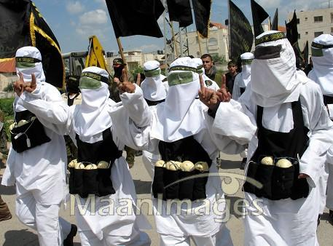 | 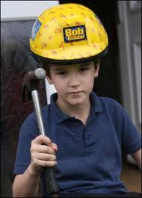 | 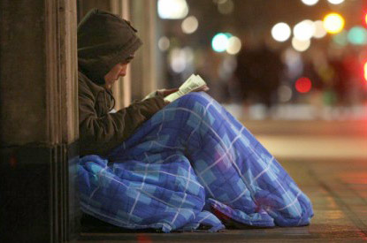
1. Altruistic Suicide | 2. ASBOs | 3. Marginalized
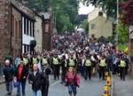 | 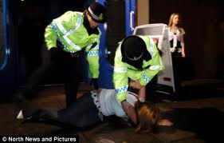 | 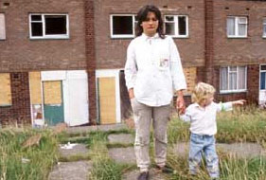
4. Media Amplification | 5. Nocturnal Economy | 6. Tipping
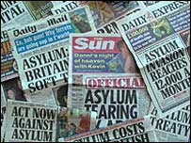 | 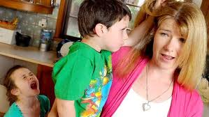 | 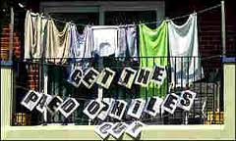
7. Moral Panic | 8. Socialisation of & lack of opportunity for women | 9. Social Cohesion
 | 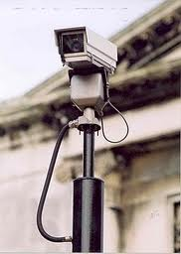 | 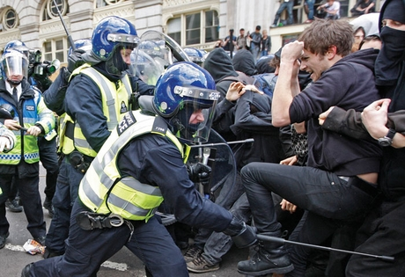
10. Institutional Racism | 11. Privatisation of public space | 12. Zero Tolerance
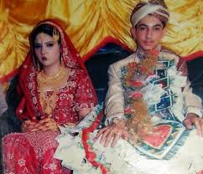 | 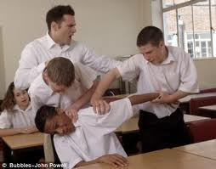 | 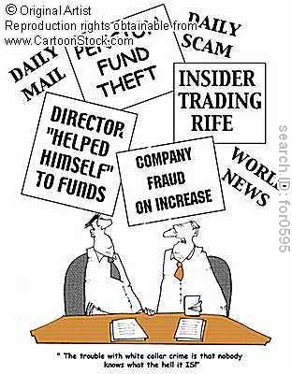
13. Fatalistic Suicide | 14. Status Frustration | 15. White Collar Crime

TEAM

Round 3: Picture Round

1. | 2. | 3.
4. | 5. | 6.
7. | 8. | 9.
10. | 11. | 12.
13. | 14. | 15.
TERMS: Zero Tolerance Suicide Social Cohesion Moral Panic
Nocturnal Economy Privatisation of public space Media Amplification Tipping
Altruistic Suicide Status Frustration Marginalized White Collar Crime Fatalistic Suicide ASBOs Concentric Zones Anomie
Socialisation of & lack of opportunity for women Institutional Racism Strain Theory
TEAM

Round 4: Pot Luck

1 | This term refers to the commonly held believe that the behaviour of observed groups cannot be trusted if they are aware they are subject to study, as they will modify their behaviour | Hawthorn Effect
2 | Philip Zimbardo created a ‘Prison Experiment’ in his university to investigate the role of prisons, the effect on prisoners and the guards. But it went badly wrong, It was called.... | Stanford Prison Experiment
3 | This approach models itself on a scientific approach, believing that with reliable, objective research, that can be replicated...that sociology can be considered a natural science. | Positivism
4 | This is where people are asked to note down the crimes they have committed over a particular period | Self-Report Studies
5 | This is a period in history which is characterised by the believe that superstition as an explanation for phenomenon is wrong, rather that all things can be explained through rational thought | Modernity/Modernism
6 | This theory refers to the way that the leisure industry has developed at night, which creates many late night offences | Nocturnal Economy
7 | This sociological theory believes that people work via symbols (e.g. language) to construct and understand society and respond to it based on their individual interpretation of it and understanding. | Symbolic Interactionist/Social Action
8 | This sociologists used covert participant observation to understand what it was like to be a member of a violent gang. His experiences where frightening and dangerous, which led to him leaving the study after just a few months | James Patrick
9 | This concept follows the idea that science develops in stages. It exists in it’s normal state where everyone agrees with the common concepts/scientific truths. Science changes as scientific revolutions occur which challenges the previous accepted believes, this new explanation is often resisted but over a period of time as evidence and research strengthens a new set of believes are adopted and so there is a new ‘scientific truth’. | Shifting Paradigms
10 | This term is used to describe multiple methods (often qualitative and quantitative) in research | Triangulation
11 | This refers to the concept of crime and deviance and the fact that it is in fact created by society itself and therefore changes over time and place | Social Construction
12 | This method of sampling is often necessary in deviant groups, since there is no sample frame. The method works by gaining the agreement of one person - a ‘gatekeeper’ and then through them a larger network is built up. | Snowball Sampling
13 | This sociologist follows the logic that a hypothesis should be scrutinised for whether or not it is false. If falsification cannot be proved, the longer this situation continues, the more likely the hypothesis is correct. | Karl Popper
14 | This theory looks at how crimes are committed as a result of calculating: 1. How attractive the target is, 2. How accessible the target is | Opportunity Theory
15 | This psychologist used experiment to understand how people transferred the responsibility of their actions, by examining the role of ‘authority figures’ in influencing peoples decision making. He created an ‘electric shock’ experiment. | Stanley Milgram

TEAM

Round 4: Pot Luck

1 | This term refers to the commonly held believe that the behaviour of observed groups cannot be trusted if they are aware they are subject to study, as they will modify their behaviour
2 | Philip Zimbardo created a ‘Prison Experiment’ in his university to investigate the role of prisons, the effect on prisoners and the guards. But it went badly wrong, It was called....
3 | This approach models itself on a scientific approach, believing that with reliable, objective research, that can be replicated...that sociology can be considered a natural science.
4 | This is where people are asked to note down the crimes they have committed over a particular period
5 | This is a period in history which is characterised by the believe that superstition as an explanation for phenomenon is wrong, rather that all things can be explained through rational thought
6 | This theory refers to the way that the leisure industry has developed at night, which creates many late night offences
7 | This sociological theory believes that people work via symbols (e.g. language) to construct and understand society and respond to it based on their individual interpretation of it and understanding.
8 | This sociologists used covert participant observation to understand what it was like to be a member of a violent gang. His experiences where frightening and dangerous, which led to him leaving the study after just a few months
9 | This concept follows the idea that science develops in stages. It exists in it’s normal state where everyone agrees with the common concepts/scientific truths. Science changes as scientific revolutions occur which challenges the previous accepted believes, this new explanation is often resisted but over a period of time as evidence and research strengthens a new set of believes are adopted and so there is a new ‘scientific truth’.
10 | This term is used to describe multiple methods (often qualitative and quantitative) in research
11 | This refers to the concept of crime and deviance and the fact that it is in fact created by society itself and therefore changes over time and place
12 | This method of sampling is often necessary in deviant groups, since there is no sample frame. The method works by gaining the agreement of one person - a ‘gatekeeper’ and then through them a larger network is built up.
13 | This sociologist follows the logic that a hypothesis should be scrutinised for whether or not it is false. If falsification cannot be proved, the longer this situation continues, the more likely the hypothesis is correct.
14 | This theory looks at how crimes are committed as a result of calculating: 1. How attractive the target is, 2. How accessible the target is
15 | This psychologist used experiment to understand how people transferred the responsibility of their actions, by examining the role of ‘authority figures’ in influencing peoples decision making. He created an ‘electric shock’ experiment.

TEAM

Final Score

Round | Score | Joker Played
1
2
3 |  | -------
4
Total |  | ------

