Postmodernists have provided a very different way of looking at crime and deviance in contemporary society; these tend to be highly critical of more traditional sociological approaches, particularly functionalism & Marxism.
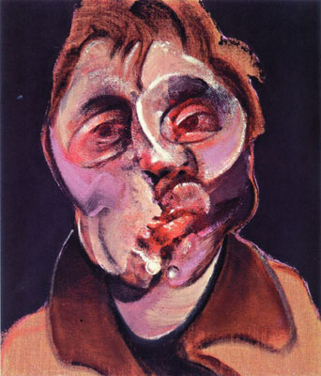
Crime & Deviance

postmodernity

Postmodernism rejects grand narratives, particularly those which seek to offer explanations of crime & deviance based on ‘science’ and ‘structural sociology’.
The post modernist account is based on three key concepts
That sounds complicated!
1. Difference ~ society is a ‘global village’ connected by mass media ~ this highlights how different we all are.

2. Fragmentation
The death of grand narratives has led to the disintegration of the traditional suppliers of norms & values (family, religion etc..). This means that society is fragmenting.
3. Incoherence

This involves ‘resurrecting the importance of the irrational’

It’s simple!
Previous sociological explanations seek to explain the factors that make people commit crime/deviance (ie: sub-cultural values, lack of socialisation, anomie, poverty, welfare dependency etc etc). Postmodernists break with this approach and argue it’s our emotions that are causes of criminal and deviant behaviour (emotions are irrational and ‘unscientific).

The third factor ‘incoherence’ is particularly important as it forms the basis of the postmodernist explanation of why people turn to criminal/deviant behaviour.

Postmodernists Levin & McDevitt argue that most crime and deviance is the result of ‘thrill-seeking’
“……thrilling activities provide an escape from the dullness of everyday rouitines. When a person commits a crime they experience feelings of self-realisation & self-expression which bring them alive”.

Fenwick & Hayward (2000)
Levin & McDevitt’s argument does not explain why this should provide thrills for some and not the vast majority of the population who tend to be law abiding.

Fenwick & Hayward
may provide one answer
to this.
BUT
“The reward for violence & theft is as much psychological as it is social. It provides the joy of exhilaration and the thrill of making someone suffer”.
Levin & McDevitt (2002)

