A Study of Crime and Deviance

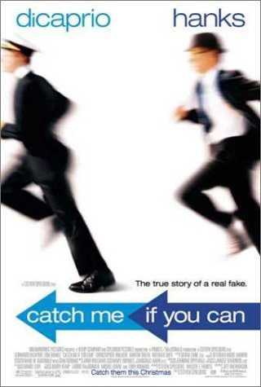

Objectives:
- To gain an overview of the Crime and Deviance Unit including key words and key concepts
- To examine the crimes of Frank Abagnale and investigate social control, deviancy, the different types of crime and the media’s involvement in deviancy.

Difference between Crime and Deviance
1. When lying about the suit: is this a criminal or deviant
act?

2. Is deviance always illegal? Explain.

3. Frank Snr says “I’m not a criminal” to the bank manager.
What is a criminal?
Why does Frank think he is not a criminal?

Creating Deviance and Creating Norms
1. Deviance is historically, socially and culturally defined
i.e. what we think is deviant depends on our way of life
and what people think and this changes.
Is smoking more deviant now than in the past? Why?

2. Social Control: The process by which people are
persuaded to obey rules/ conform.
Informal Social Control = Socialisation
Formal Social Control = Laws, police etc.

When Frank is expelled from school what are the
different ways in which his parents act? How do you think
this affects Frank?

3. How do Frank’s parents persuade him to obey the rules/
conform?

Breaking the law or breaking norms?
1. When Frank tries to cash fake cheques is this a deviant
act or a crime? Explain.

2. When do Frank’s actions become criminal?

Social Control
1. Formal Social Control: Agencies of Social Control:

Police | What makes them Formal?
Courts
Prison | Why are they interested in Frank’s activities?
Government

2. The media is a form of informal social control. Why is
Frank idolised in the media and referred to as the
“Skyway man”? Why are the public not angry at him?

Types of Crime
1. Types of crime:
White collar crime = crimes against companies/
government -crimes committed as a result of people’s
jobs. (middle class workers have more opportunities to
commit this type of crime).
What crimes has Frank committed?

2. Why do people not care as much about white collar
crimes?

3. How may white collar crime be more harmful to people?
Age and Crime
1. Frank’s mother says “It was a thousand dollars; half the
kids his age are on dope, throwing rocks at police”. Why
does Frank’s mother think he is not a criminal?

2. If Frank was older, he may not have committed these
crimes. Why?

Deciding on Deviance
1. When Frank becomes a doctor is it a more deviant act
than pretending he was a pilot? Explain.

2. Why are we now supporting Frank even though he is a
criminal? How has the film shaped our views.

