CORE CONCEPTS

ACTIVITIES

1. CULTURE

Activity 1. The Components of Culture

In the video we’ve defined the concept of culture in broad terms as a “way of life” specific to a particular society and this exercise is designed to introduce students to a range of basic sociological concepts (such as roles, values and norms) related to this general concept of culture – something we can do in two ways:

1. Culture involves thinking about the kinds of things people share or have in common as a group (since one obvious characteristic of “our culture” is that it is different to “other cultures”). The objective here, therefore, is to get students to think about how we behave socially – as memebers of various groups (large and small).

In small groups, ask your students to identify some of things they think the members of “our society” have in common. If you have already introduced definitions of roles, values and norms ask them to think specifically in these terms, otherwise head-up a white-board / OHT with the following, putting brief definitions under each heading if necessary (for example “a role” is a part we play in life):

Roles
Values
Norms

Ask each group to suggest things we have in common in our cukture under each heading. This will start to produce illustrations of the concept of culture that can be developed in part two.

2. You can illustrate how roles, values and norms are both related (each role, for example, involves a set of values and norms) and form the basic building blocks of any culture by thinking in terms of the “3Rs” (Relationships, Rules and Responsibilities):

You can do this by asking your students to focus on their school as “a culture” (or subculture if you prefer). In small groups, ask the students to identify:

The various relationships involved in the “school culture” (this will involve identifying various roles – teacher, student, caretaker etc. that make-up the school role set).

How these relationships are linked – and held together – by various responsibilites (values)

How these relationships are governed by formal and informal rules (norms)

If you want to extend this exercise further the above can lead into a more-specfic discussion about “the student role” and “classroom behaviour” – get the students to reflect on their own behaviour and what might be “reasonably expected” of members of the class – a subcultural group within the school / college (this can, if you wish, become a blueprint for laying-down some rules of (student) behaviour: attendance, punctuality, classroom behaviour, homework…).

Activity 2. British Culture

The concept of culture has a range of dimensions or aspects that it is useful for students to explore, for a couple of reasons: firstly, by looking at different dimensions (political, economic, cultural and so forth) they start to appreciate something about the complexity of the concept of culture. Secondly, there are many different types of behaviour and beliefs that can be characterised as being “typical” of British culture – and this exercise is designed to both draw these out and suggest to students the depth of their existing knowledge about “British culture”.

This Activity requires students to identify behaviours and beliefs characteristic of “British culture”. It can be done individually, but it’s more fun if carried out in small groups. Draw the following table (or something similar) on a whiteboard or flipchart and ask each group to identify examples of “British behaviour and beliefs”. Give the groups a few minutes to identify examples and then, as a class, add their examples to the chart.

Once completed you will have a set of examples to illustrate what your students believe to be norms and values characteristic of British culture.

Aspect of Culture | Behaviour typical of “British culture” | Typical beliefs of “British culture”
Politics
Family
Work
Education
Media
Religion
Science

If you need some examples to get the groups thinking you could add the following to the chart:

Aspect of Culture | Behaviour typical of “British culture” | Typical beliefs of “British culture”
Politics | Legal system – law abiding | Fair trial
Family | Marriage / cohabitation | Romantic love
Work | Employer / employee | Work for money
Education | Attending school (5 – 16) | Qualifications important
Media | Watching TV | Private / Public ownership
Religion | Prayer | Christianity / Islam
Science | Medical Surgery | Keeping people alive as long as possible
Activity 3. Every Picture Tells a Story

The concept of cultural diversity is an important one for sociology because if we can compare cultures and find differences between them this suggests that the causes of human behaviour (why people behave in the ways they do) are rooted in their social environment.

This activity can be used to demonstrate two ideas:

1. There are a number of fundamental sociological concepts that can be applied to an understanding of human behaviour across different cultures. These concepts provide people with a structure to their behaviour by specifying some fundamental behavioural rules – all human behaviour, for example, involves things like roles, values and norms (and this part of the activity can be used to introduce the concept of social structure).

2. How people interpret these concepts (or basic structural rules) differs widely form society to society and culture to culture. This activity, therefore, can be used to demonstrate two ideas:

1. Cultural continuities – the fundamental traits that underpin all human behaviour.

2. Cultural diversities – the different ways people of different cultures develop different ways of behaving within the same general cultural setting.

- If necessary, a simple way of getting the distinction across is to compare two faces – each shares things like: nose, mouth, lips, ears etc. (continuities) but there are distinctive facial differences between people (diversities).

Split the class into an even number of small groups.

Copy the following photographs – a market in England, a market in India and a market in Egypt - onto an acetate for OHP viewing (or simply provide photocopies for each group).

Group 1 looks for examples of cultural continuities (things that are the same in each culture).

Group 2 looks for examples of cultural diversities (the different ways these two cultures perform a similar activity differently).

To guide their observations, ask the students to think about the following categories:

Roles
Values
Norms

This activity also presents a good opportunity to introduce and apply the following concepts:

Social status
Positive sanctions
Negative sanctions

If you want to give your students an example to get them started:

Continuity: In each situation there are people playing the role of customers

Diversity: How they play that role is different – e.g. Egyptian customers are more likely to haggle with the shopkeeper over prices.

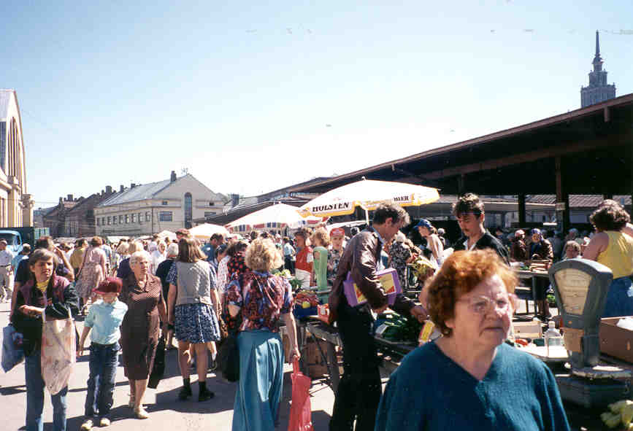

English market

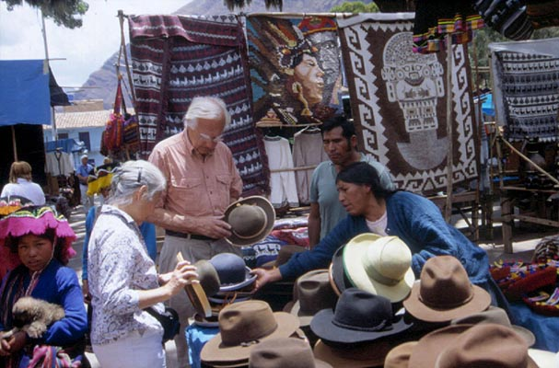

Indian market

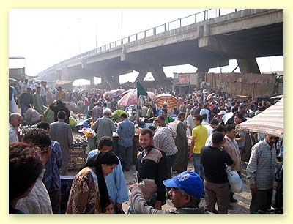

Egyptian Market
2. SOCIALISATION

Activity 1. Instincts

Sociologists generally favour cultural explanations of human behaviour over genetic / biological explanations and one way to get this idea across to students is to ask them to identify any form of human behaviour they believe is instinctive rather than culturally created.

This Activity tests whether or not it’s possible to identify human instincts; it’s a useful exercise, not simply to test this idea, but also because it can be used to lead into a discussion of learned behaviour and socialisation.

1. Define the concepts of instinct and biological drives and make sure the students understand how they differ.

2. Head-up a white board (or similar) in the following way:

Behaviour | Instinctive? | Biological Drive? | Culturally Influenced?

3. Ask the students – either as a whole class or in small groups - to identify any form of behaviour they think could conceivably be based exclusively on instinct (for example, eating, sleeping, crime, looking after children…). Write each suggestion in the “Behaviour” column.

Once there are no more suggestions:

a. Tick any behaviour that falls into the “Biological Drive” category (this will include things like breathing, bodily functions, etc.).

b. Tick any behaviour that falls into the “Culturally Influenced” category (that is, any behaviour where we can decide whether or not we do it – this will put paid to things like crime (many people never break the law) and looking after children (many people choose to remain childless, or they employ other people to look after their children).

Once complete you’re likely to find lots of ticks in the culture category, a few ticks in the biological drive category and very few, if any, in the instinct category…

Activity 2. The Socialisation Game

This is a simple board game activity that can be used to illustrate the idea of gender socialisation.

If played as a class, project the game board (socialisation game.pdf) it onto a whiteboard.

Split the class into two groups – males and females.

Each group takes it in turn to role the die and their counter moves around the board accordingly (respective positions on the board can be noted using a marker pen, for
example, if using an acetate, otherwise team counters will be needed), following the instructions printed on whatever square they finally land on.

The first team to reach the Finish square wins…

Activity 3. Agencies of Socialisation

In this activity students are required to apply concepts like values, norms and sanctions to a number of different agencies of socialisation. If the class is large, divide them into small groups and give each a specific agency to research (Family; Peer group; Education; Work; Media and Religion gives a good spread of agencies). If the class is small either individually or in pairs get them to choose an agency.

Ask each group to head-up a sheet a sheet of A4 paper (landscape orientation works best) in the following way:

Agency of Socialisation: [Agency]

Roles | Values | Norms | Positive  Sanctions | Negative Sanctions

Each group should identify, for their chosen agency, examples of the roles people play, values they might develop, norms they’re expected to obey and examples of positive and negative sanctions they employ.

Once each group has completed the activity the information can be shared in a range of ways, such as in-class presentations by each group, photocopying and sharing the information each has collected and so forth.

3. IDENTITY

Activity 1. Who am I?

The main objective of this activity is to demonstrate how social and personal identities are linked, in the sense of seeing how students draw on a range of the former as a means of expressing the latter.

Aside from demonstrating how we go about constructing identities, this activity can be used to illustrate a couple of further ideas, if required:

1. The relationship between social structures (in the shape of social identities) and social actions (in the shape of personal identities).

2. How even what we like to think of as our “individuality” is, in some ways, shaped by the cultural groups to which we belong (either as ascribed belonging – as with the family – or achieved belonging in terms of something like friendship groups).

Ask each student to answer the question “Who are you?” by writing down 10 things (at least – it can be more if necessary) that they believe expresses their sense of identity (the essential things – such as their name, whether they are male or female, gay or straight or whatever - that they believe make them “who they are”).

Most students will invariably draw on a range of cultural factors (age, gender, class, region, and ethnicity), physical features (“good looking”) and things that describe their individuality, such as easy going, loud, lazy and so on. Remind students of the distinction between social and personal identity made in the video (or show them the relevant section ) and invite individual students to explain to the class “Who they are” by:

1. Listing the things that contribute to their sense of identity.

2. Explaining why they choose each of these things.

Once completed this can be used to lead into a class discussion about the relationship between personal and social identities (for example, if the former are based around the latter what does this tell us about the relationship between the individual and society?)

Activity 2. Gender Socialisation and Identities.

In the previous activity it’s highly likely that, as in the video, most students will have referred to gender as a major source of their personal identity and this activity builds on this recognition to explore the idea of gender socialisation and difference and the role of culture in shaping gender identities.

It also helps to establish synoptic links with two other popular A-level topics, education and deviance (as well as, a little more abstrusely, Stratification and Differentiation in terms of something like different life chances).

Give your students a copy of the following report (or copy it to acetate and display for the whole class) to read:

Gender stereotypes still hamper young
Will Woodward, Education editor: The Guardian, 20/09/2000
“Adolescents are still unable to shake off gender stereotypes that appear as entrenched as ever…Inside, outside and beyond school, young men and women are under continuing pressure to conform to traditional behaviour.

At school, women avoid physics and information technology and choose English, biology, history and modern languages. "Young women find it easier to ask for help than young men, who find it harder to admit a lack of knowledge," the report, “Young People and Gender” says. Boys are more likely to break the law - a gap which extends after the age of 14 - or be involved in crime, alcohol abuse and illegal drugs.

Girls, who are more likely to be concerned about their body image and weight, are much more likely to start smoking. Suicide rates are higher for men and double the number of boys die at 17. Boys are less likely to visit their GP or to use other health services. Girls are more at risk of depression, eating disorders and self-harm.

Boys "take greater risks and feel greater pressure" to be sexually active and find it harder to admit inexperience. But "in spite of the notion of 'girl power', young women still find it problematic to say no to sex and negotiate the use of contraception".

At work, young men are more likely to want managerial or professional jobs - 75% compared with 25% for women, who are concentrated in personal service industries with part-time jobs and lower wages. "The need to conform to masculine stereotypes prevents young men from joining traditionally female careers." Although more young men are officially unemployed, a large group of young women remains outside employment, education and training opportunities because of caring responsibilities.”.

The article can be used as the basis for a discussion of gender stereotyping in three ways:

1. Ask students to individually write down five ways in which they think their life would have been different if they had been born a boy rather than a girl and vice versa.

Next, ask your students which of these differences they think are primarily due to biological causes (e.g. males are stronger, women bear children) and which are due to cultural causes (e.g. expectations about appearance, educational and work opportunities and so forth).

Ask a selection of students to volunteer their answers to the rest of the class and briefly discuss the implications of these answers – what, for example, does this tell us about the relationship between biology (the sex we are born as) and culture (how social identities shape the way we see gender and personal identities)?

2. Either ask your students to individually write short answers to the following questions or use them as the basis for a discussion about gender:

a. Are there “masculine” and “feminine” stereotypes in adult society (and if so what sort of “traditional behaviours” do they involve?).

b. Why do boys and girls still prefer different subjects at school (do you have any personal experience of pressure to take or reject certain subjects)?

c. Why are boys are more likely to break the law?

d. Why are girls more concerned about their body image and weight?

e. Are there different pressures placed on boys and girls (from whom?) concerning sex and sexuality?

3. Finally, ask your students, in small groups or as a class, to consider how gender identities might have changed since their parents were young. This will help them to reflect on the way social changes (such as globalisation) have impacted on changing gender socialisation and identities.

Activity 3. Personal Identities

In this exercise we delve a little more deeply into the idea of personal identities by building on work completed in an earlier Activity.

1. Ask your students to select one aspect of their personal identity from the list they created in Activity 1 and get them to think about and identify at least three reasons they would use to justify how and why this aspect of their identity is important to them.

Once this has been done ask students to individually volunteer their reasons to the class and lead the class into a discussion about the role of others in the process of identity formation (for example, making comparisons with others, being defined by others etc.).

2. Ask your students to recall and describe situations in which their personal identity (or some aspect of that identity) was confirmed or contradicted by the reactions or responses of others towards them (you can, if you want to structure and expand this discussion, give them categories or situations to think about – the home, the school, the workplace and so forth).

In our experience students enjoy this Activity because it’s an excellent way of illustrating how even the ways they view themselves as distinct individuals are shaped by social relationships; talking about themselves and their own experiences also helps to make sometimes abstract sociological observations and arguments real to students.

