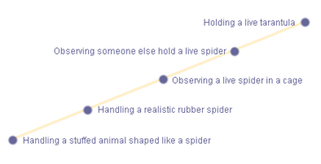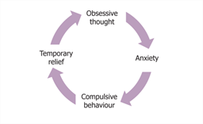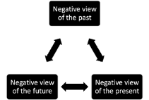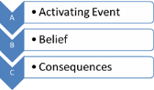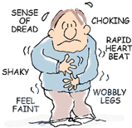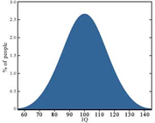

**Jahoda, 1954, suggested…**

**Statistical infrequency suggests…**

**Deviation from social norms suggests…**

**Failure to function adequately suggests…**

Emotional characteristics

Acquired through …………… conditioning, this suggests…

**Can anyone be normal?**

Psychopathology can be defined as…

**Depression can be treated through…**

**This involves challenging…**

**Therapists usually combine both…**

Explanation:

Advantages

* .
* .
* .

Disadvantages

* .
* .
* .

Treatment:

Advantages

* .
* .
* .

Disadvantages

* .
* .
* .

|  |  |  |  |
| --- | --- | --- | --- |
| **Treatment** | Process | **Strengths** | Limitations |
| Flooding |  |  |  |
| **Systematic desensitisation** |  |  |  |

Neurological theorists suggest OCD is caused by…

Genetics theorists suggest OCD is caused by…

Psychopathology!

Cognitive characteristics

Behavioural characteristics

Is drug treatment the right treatment?

OCD can be treated by…

Beck suggested you could explain depression as…

Ellis disagreed and argued it can be explained by…

Maintained through …………… conditioning, this suggests…

The two process model can explain phobias as it suggests…

**What makes someone abnormal?**