Biopsychology Learning Table 2: Neurons and Synaptic Transmission
The Structure and Function of Neurons  - Neurons are cells that are specialised to carry neural information throughout the body.  - Dendrites receive signals from other neurons or sensory receptors. They are connected to the cell body (the control centre). The impulse travels from the cell body along the axon, where is stops at the axon terminal. Myelin sheaths allow nerve impulses to transmit more quickly along the axon.  - Sensory neurons – carry nerve impulses (e.g. vision, taste touch) to the CNS.  - Relay Neurons – Allow sensory and motor neurons to communicate with each other. Only found in brain and spinal cord.  - Motor Neurons – form synapses with muscles and control their contractions. | 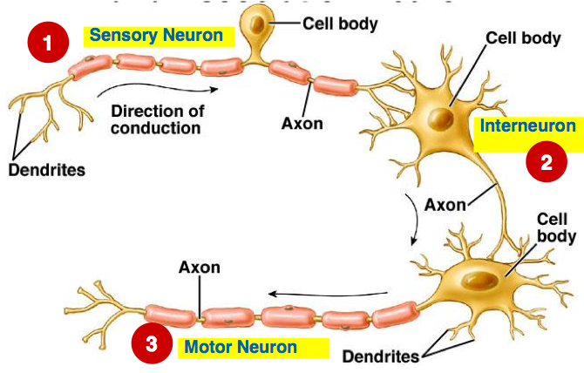  Myelin Sheath  Relay Neuron
Synaptic Transmission  - Each neuron is separated from the next by a tiny gap called a synapse.  - Signals in the synapse are transmitted chemically.  - When an electrical impulse reaches the end of the neuron (the pre-synaptic terminal) it triggers the release of neurotransmitters from tiny sacs known as vesicles.  - These neurotransmitters diffuse across the gap and are taken up by receptors. The chemical message turns back into electrical and the impulse is carried down the next neuron.  - Different receptors respond to different neurotransmitters depending on their shape. | 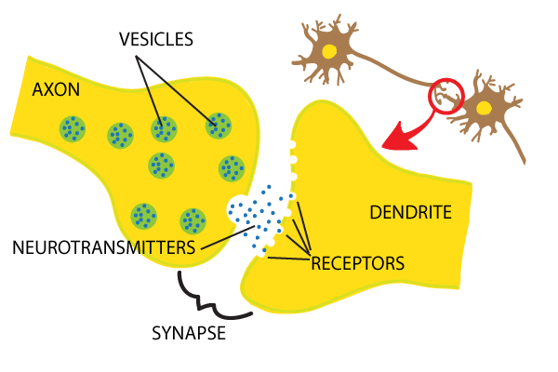  PRE-SYNAPTIC TERMINAL
Excitatory and Inhibitory Neurotransmitters | Neurotransmitters can either have an excitatory or inhibitory effect on the neighbouring neuron. Excitatory neurotransmitters increase the likelihood of the neighbouring neurone firing (acetylcholine and noradrenaline). Inhibitory neurotransmitters decrease the likelihood of the neighbouring neuron firing (GABA and serotonin).

