Learning Table 1: Key Concepts
Sensation & Perception
Sensation |  |  |  | Perception
Sensation refers to the information that is collected by our sense organs. The sensations or information for visual perception are light waves picked up by the eyes. These light waves are sorted out by the retina into electrical information. This is then sent across the brain to the visual cortex (the processing centre) at the back of the brain. |  |  |  | Perception refers to the process in which the sensations from the eyes are turned into meaningful images by the visual cortex. Sometimes there can be a mismatch between a sensation and our perception. A visual illusion is where we see something that is false or distorted.
Types of Optical Illusions
- Geometric Illusions |  | - Ambiguous Figures |  |  |  | - Fictions
Which line is longer? When you look at the horizontal lines in between the railway lines your brain persuades you that the top one must be further away and therefore wider. However, if you measure them – they are identical. |  | This is a picture that can be seen in more than one way. Stare at the grey side, you will see that sometimes it appears at the front and other times at the back. |  |  |  | This is seeing something which is not actually there. There is no white triangle in the middle of the drawings, but it seems as if there is.
 |  | 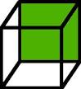 |  |  |  | 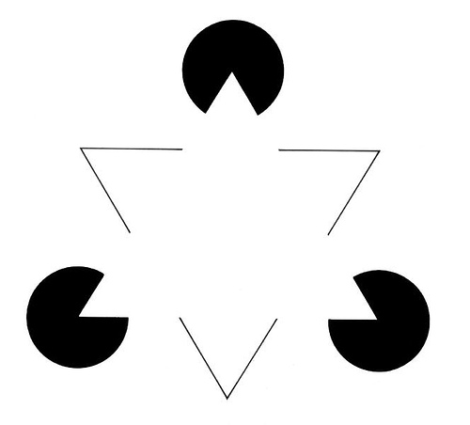
Everyday Perceptions
We do not need to create illusions to show the power of perception. Everyday perception is full of interesting puzzles, such as how objects and living things change shape as they move about but we still see them as remaining the same size.
Visual Constancies
Visual constancies allow us to see things as remaining the same even though their physical characteristics are constantly changing.
Shape Constancy – the tendency to see an object as keeping its shape even though we see it from different angles. |  |  |  | Colour Constancy – the tendency to see colours as remaining the same despite different lighting.
Depth Perception
- Depth perception also illustrates the difference between sensation and perception.
- When we sense or look at the environment around us, the image on the back of our eye is two-dimensional – like a photograph.
- However, the world we perceive in our minds is the three-dimensional one we live in.
- Depth perception refers to the ability of our eyes and brain to add a third dimension, depth, to everything we see.
- Linear Perspective:  As you look down a stretch of motorway the outside lines of the road and the white markings appear to come together in the distance. This allows us to interpret the distance of the road, and is known as linear perspective. | - Height in the Plane: This is a device or trick used by painters. If the image of an object is higher to the eyes (i.e. above the horizontal halfway line) it is often seen as a further away or more distant than other objects in the lower part of the painting. |  | - Relative Size: This is when we expect two objects to be the same size and when we look at them they are not. Our brain interprets this to mean that the bigger one is closer and the smaller one is further away. So objects that are smaller are usually perceived as further away. |  | - Superimposition: If one image blocks or lies across the image of another object, we decide that the first object must be a bit closer to us. |  | - Texture Gradient: Imagine you are standing on a beach and are looking along it. The grains of sand and pebbles are pretty clear when you look down at them. However when you look along the beach they appear to blend into one and give a smoother, less detailed texture. We use this effect to spot distance.
