LT1: Atypical Behaviour Key Concepts
Phobia | Description
A-G-O-R-A-P-H-O-B-I-A (agoraphobia) | An extreme fear of being in public spaces away from the safety of the home.  E.g. shopping centres or public transport. People often feel confined to their own homes | 
S-O-C-I-A-L P-H-O-B-I-A (Social Phobia) | An extreme fear of being exposed or embarrassed during social contact  -Sufferers are very anxious about what people may think of them  -They worry that they will act in an embarrassing way in public | 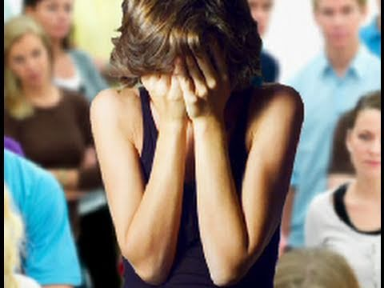
S-C-H-O-O-L P-H-O-B-I-A (School Phobia) | An extreme fear of attending and being in school  -It is not the same as truanting  -Non-attendance is related to anxiety | 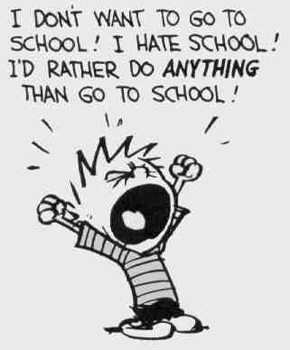
A-C-R-O-P-H-O-B-I-A (Acrophobia) | An extreme fear of heights  -Anxious about being high up somewhere | 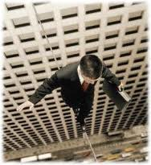
A-R-A-C-H-N-O-P-H-O-B-I-A (Arachnophobia) | An extreme fear of spiders  -Suffers’ reactions will differ: in extreme cases some people may struggle to cope with a cartoon picture of a spider | 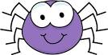
Note: Students always struggle to spell the words correctly and this is essential for the exam. Make sure you know the definitions and also how to spell the words correctly.

