Criminal Behaviour: Core Theory
The Biological Theory
The biological theory argues that criminal behaviour is inherited. This means that the person has already been genetically programmed through their DNA to make them commit crime. On this basis we would expect criminal behaviour to run in families. If criminal behaviour is genetically inherited, the next question is: What effect do genes actually have? What do criminal genes actually do to people to make them break the law?
- Brain Dysfunction
One theory is that genes can effect brain development. This suggests that criminals have abnormal brains. Areas of the brain seen to be dysfunctional in some criminals include:
Pre-frontal Cortex  This area of the brain is underactive in some criminals. It is the part of the brain where humans are conditioned to form an association between fear and anti-social behaviour. So criminal behaviour can occur because people with underactive pre-frontal cortexs are not afraid to commit anti-social behaviour such as crime. |  | Limbic System  This area of the brain controls aggressive and sexual behaviour. Scan show increased activity in this area in criminals compared with non-criminals. The amygdala is a specific part of the limbic system and controls emotions, such as when someone responds with sympathy to a sad face. Research shows that the amygdala does not function normally in the brain of many psychopaths. Therefore people with a faulty limbic system would be more likely to engage in aggressive and sexual behaviour meaning they are more likely to commit crime.
- Facial Features
If there is a gene for criminal behaviour, it is possible that the same gene could affect appearance as well as behaviour. Some psychologists argue that criminals look physically different from non-criminals. The facial features that have been associated with criminals include: asymmetrical faces, low and sloping foreheads, glinting or glassy eyes, high cheekbones, large protruding handle-shaped ears, crooked, flat or upturned noses, fleshy lips, strong jaws, prominent chins and lots of hair.
Criticisms of the Biological Theory
- One Single Gene?  P: One issue with the biological theory of criminal behaviour is that it is too simplistic.  E: This is because there cannot be one criminal gene that accounts for all criminal behaviour.  E: For example, the same gene cannot be responsible for violent crimes such as rape, for intellectual crimes such as fraud and for crimes against property such as theft.  L: This therefore reduces the applicability of the biological approach in its attempt to account for criminal behaviour as it cannot be applied to all types of crime. | - Crime is Social Constructed  P: Another problem with the biological theory of criminal behaviour is that it ignores the fact that crime is relative to time and culture.  E: For example, a person may be considered criminal if they helped a person die in the UK but not if they helped a person die in the Netherlands.  E: This is an issue because it is obvious that their genetic make-up cannot change between cultures!  L: This suggests that the biological approach does not offer a full account of criminal behaviour. |  | - Not Reliable  P: A weakness of the biological approach is that the evidence to support its claims is not reliable.  E: This is because brain dysfunction is only evident in some criminals, so it does not reliable predict whether someone is going to be a criminal or not.  E: For example, famous cases such as Ian Brady (the moors murderer) may not have a faulty limbic system, yet he still committed atrocious crimes.  L: This therefore casts doubt over the credibility of the biological approach and also its ability to predict criminal behaviour. | - Reductionist  P: A major issue with the biological theory of criminal behaviour is that it is reductionist.  E: This is because it reduces the complex behaviour of criminals down to single genes or differences in brain functions. Although this allows criminal behaviour to be studied in a scientific and empirical way, it does not take into account the influence of the environment on criminal behaviour.  E: For example, the fact that crime can be seen to run in families can equally be explained by the theory that children learn their criminal behaviour from their parents and others around them.  L: This questions the overall credibility of the biological assumptions. In order to fully understand the complexity of criminal behaviour, we must take into account the role of both nature and nurture.
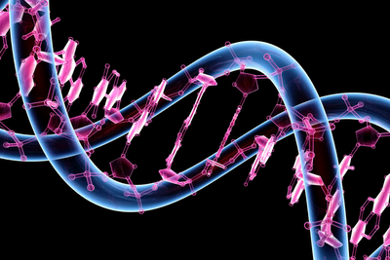 | 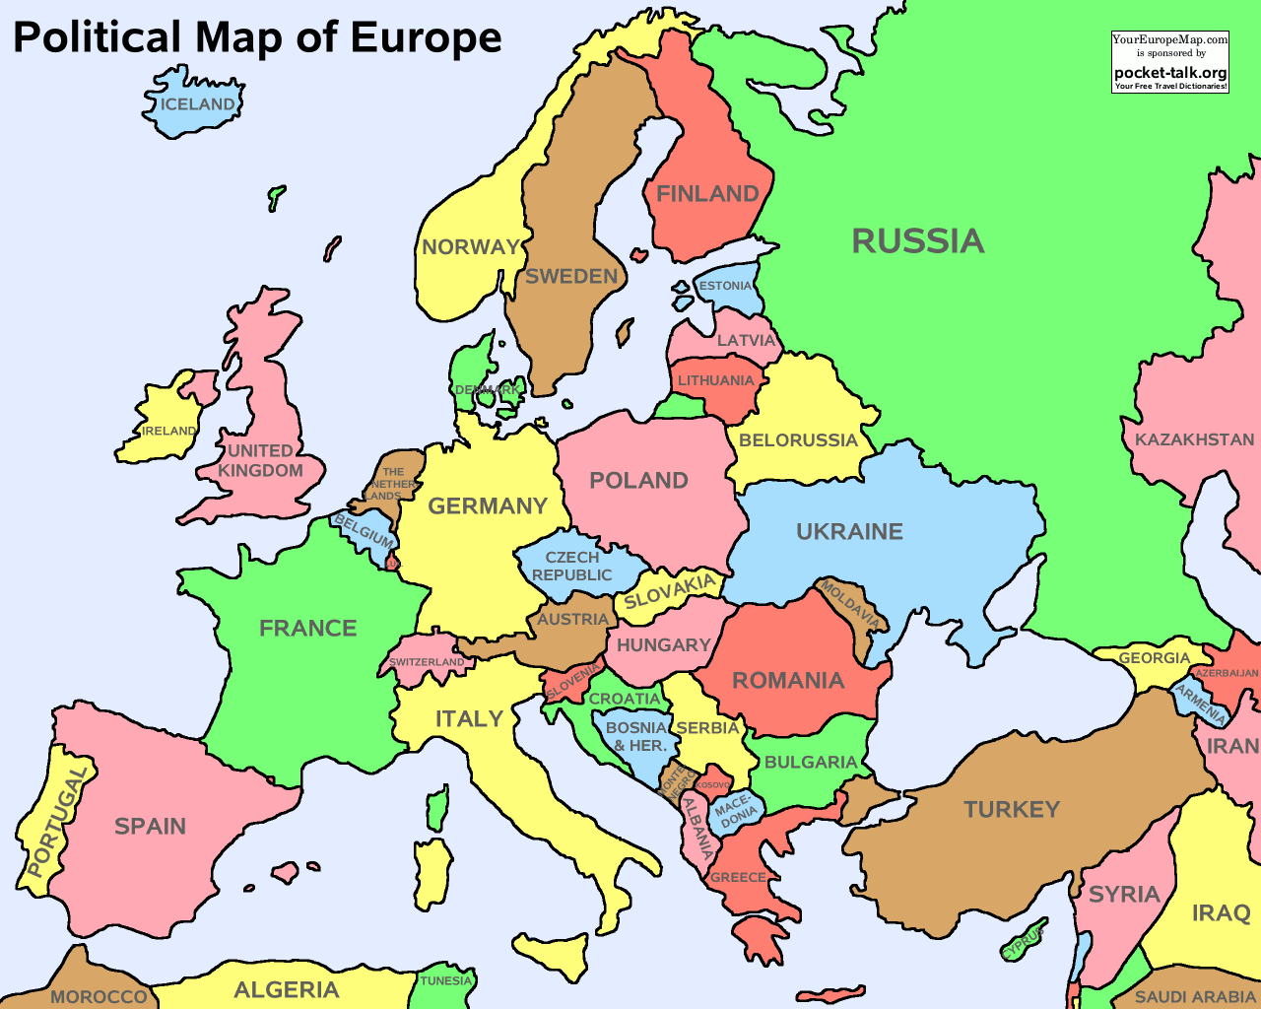 |  | 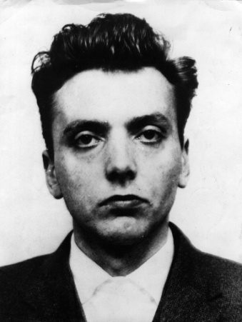 | 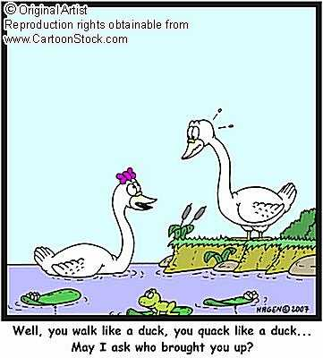

LT2: Core Theory
Constructivist Theory of Perception
The constructivist theory proposes that we construct our perception of the world based on what we see in front of us as well as past experiences. This theory supports the idea of top-down processing. This means that when the brain is sorting out objects it makes use of past experience, including:
- prior knowledge
- cultural features
- motivation
- expectations
- memory
Perceptual Set
Perceptual Set refers to the tendency to perceive a scene, situation or object on the basis on what you expect to see.
Factors Demonstrating the Role of Perceptual Set
Expectations  You’ve probably already experienced this when meeting a friend outside the cinema or shops. There may be lots of people milling around but you can pick out your friend easily because you are expecting to see them there. You might not notice them somewhere else because you were not expecting them to be there. | Motivation  How we are feeling can affect what we see. Research showed that hungry or thirsty people saw pictures of food and drink as brighter than pictures of other objects, but that the difference disappeared when they were allowed to eat and drink.
 | 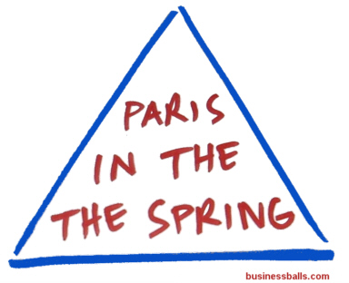

Learning Table 2: Core Theory
Piaget’s Stage Theory of Cognitive Development
 | Piaget’s theory was the result of his work in the 1920s in Paris, while looking at new intelligence tests. He noticed children of the same age often got answers wrong in the same way. They were thinking alike, but this changed with age. He observed his 3 children at home and playing with friends. He kept detailed diaries of things they said and did as they matured. From Piaget’s observations with children, he watched them problem-solve and asked them to explain the reasoning behind their decisions.
 | Stage Theory
 | A Stage Theory means that:  - Development follows a fixed (invariant) order or pattern  - The behaviour in question, e.g. language, gets better by the stage  - The pattern is true for everyone – it is universal |  |  |  | - Piaget argued that children are scientists because they are not just passive observers. They are actively involved in making sense of what they see, hear, feel and discover – just like scientists.  - He proposed that most children develop their thinking in clear stages. He came up with 4 stages of cognitive development.
 | The Stages of Cognitive Development
 | Stage | Age | Characteristics (You need to know 2 per stage for a 10 mark question)
 | The Sensori-Motor Stage | 0 – 2 yrs | - Babies spend their time examining their surroundings and placing objects into their schemas.  - Body Schemas: The infant recognises that it exists physically (for example it can recognise itself in the mirror).  - Motor-Coordination: The infant learns to coordinate different body parts.  - Object Permanence: The infant knows that an object exists even if they cannot be seen. At around 8 months, babies will look for objects because they have developed object permanence.
 | The Pre-Operational Stage | 2 – 7 yrs old | - Children use symbols and words or mental pictures to solve problems however, they still cannot do:  - Animism: Treating inanimate objects as if they are alive just like themselves (for example they tell off a table if they hurt themselves on it).  - Reversibility: Unable to work backwards in their thinking (for example, 4 yr old Holly is asked ‘do you have a sister? To which she replies ‘Yes, Sally’ but when asked ‘does Sally have a sister?’ she replies ‘no’.  - Egocentrism: A child can only see/think about the world from their point of view. (Demonstrated with the 3 mountains experiment).
 | The Concrete Operational Stage | 7 – 11 yrs old | - All the characteristics of the pre-operational stage are dropped.  - Linguistic Humour: Children can understand and enjoy word games and double meanings.  - Seriation: The ability to put things in rank order.  - Conservation: When children know the property of certain objects remain the same, even if the objects appear to change. (Demonstrated with the beaker experiment).  - They are able to think in concrete terms but cannot yet think about abstract concepts. (Things they can’t see in front of them).
 | The Formal Operational Stage | 11+ yrs | - They can think about and solve sophisticated adult problems.  - For example, a 15 year old can compare several theories about why dinosaurs disappeared (grown up thinking also known as hypothetical thinking).  - Hypothetical thinking allows people to see the bigger picture.  - They can develop a general principle they can apply to other situations.
Learning Table 2: Core Theory : Social Learning Theory
AO1 – Social Learning Theory
This theory argues that NVC is a learned behaviour rather than a natural instinctive one. From this view NVC learnt through the following processes :

- Observation – We see how other people in our community or culture communicate with each other e.g. seeing greetings such as waving
- Imitation – It is easier to imitate (copy) the behaviours we see more frequently or more easily (i.e. those in our immediate community or culture) e.g. seeing people wave to each other regularly upon seeing each other
- Reinforcement – We are rewarded for communicating as expected because people like it when we follow cultural norms e.g. we wave at someone and they wave back or smile at us
- Punishment – We are reluctant to repeat a behaviour if it has been punished (e.g. we were ignored or ridiculed) or has cause offence, so NVC that is not accepted by a culture should ‘die out’ within it.
- Role models – The person or persons who are seen or watched and listened to. These are often influential adults, such as parents, but can be celebrities, older siblings or our peers.

If NVC is a learnt behaviour as argued by SLT, then how we communicate would depend on our upbringing. This assumption can be tested by looking at different cultures to see if there are differences in the way that people in each communicate.
Cultural variation can be observed in how people great each other. In Brazil, the custom is for women to exchange kisses twice if they are married and three times if they are single whereas in Saudi Arabia, if you are a woman, no body contact is involved at all when meeting others.

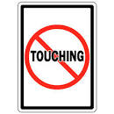
Learning Table 2: Core Theory : Humanistic Theory of Self
AO1 – Humanistic Theory
In the 1950s Maslow and Rogers developed the humanistic theory. This theory puts a lot of emphasis on people being individuals. In other words, humanists see us as unique and as having free will.
The main humanist ideas include:
- Each of us always has the power to decide our on our actions.
- The present is what we should focus on rather than past experiences.
- We are all motivated to become the best that we can be, to fulfil our potential.

Self-Concept
Carl Rogers claimed that our self-concept begins to develop in early childhood between the ages of about one and two years, and it is in the hands of parent(s) and others close to us at that early age. The self-concept is basically how we perceive ourselves. How we see ourselves depends on how others reflect back to us. For example, if someone keeps telling you that you are a ‘good laugh’ you will see yourself as being fun.
Research shows us that young children tend to see themselves in very physical terms and will often describe what they look like. Older children focus more on their social roles when they describe themselves, talking about who they are, what they do or what they are good and bad at. Teenagers and adults are much more aware of their psychological selves and often describe their traits.

Self-Esteem
Self-esteem is a measure of how much we value ourselves.
As well as our self-concept, Rogers also talked about the ideal self. This is the person we would ideally like to be. For teenagers and adults this ideal self is often described in psychological terms (e.g. ‘I wish I was more organised’ or ‘I wish I was more understanding’). According to the humanistic theory it is the difference between the self-concept and the ideal self that determines someone’s self-esteem. If the self-concept and ideal self are incongruent, it means there is a big gap between them. This leads to low self-esteem. This is because the person they want to be appears to be far away from the person they think they are. But, if someone’s self-concept matches their ideal self they are more likely to value themselves much more as they as already more or less who they want to be.
Rogers claimed that if self-esteem was low, it could be raised using unconditional positive regard. This involves offering love, care and respect to make us feel happy in ourselves (positive) and with no conditions, or ‘no strings attached’ (unconditional).
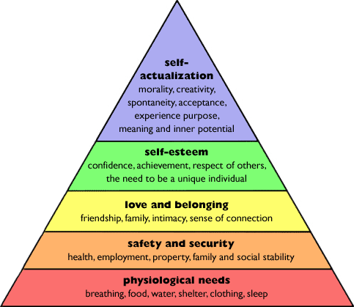
Self-Actualisation
This refers to the development of your unique human potential to become your ‘best possible’ person. In other words, it is achieving your ideal self. Rogers believed that we all have a tendency to work towards our ideal self, but we need help from others to do this.
Maslow came up with a hierarchy of needs that have to be met in turn before we can self-actualise. From birth we set out on this upward journey of personal growth.

LT 2 Sex & Gender Core Theory: Biological Approach
- Biological Theory
Biological Approach: Believes that an individual’s gender is decided at the same time as their sex is decided – at conception. When a new foetus is formed, it has 2 sex chromosomes as part of its genetic make-up. This pair of chromosomes decides whether this will be male (XY) or female (XX). After 6 weeks of pregnancy, the sex chromosomes have an effect on the development of the gonads. In males the Y chromosome ‘switches on’ a hormone in the male foetus making the gonads into tests or the gonads will turn into ovaries. These gonads then produce hormones which are testosterone in males and oestrogen in females. These hormones affect the brain and behaviour of the child. In males, testosterone makes them more aggressive and competitive and gives them superior maths and visual skills. Whereas in females, oestrogen makes them more sensitive and caring and have better communication skills.

- Evolutionary Theory
Evolution:
The biological approach also believes that that human behaviour and gender is instinctive and that instincts have helped us to survive and reproduce. So individuals have physical differences to help them reproduce (penis or vagina) and psychological differences to help them reproduce.
- Evolution may explain why females appear more caring and sensitive. Since they have to carry and then raise the young, and breast feed, they need to be better equipped with needy babies. Additionally, they need superior communication skills so they can teach their young or for sharing childcare with other mothers.
- Evolution may explain why males appear more aggressive and competitive. This is because they have to fight for the resources to provide for their partner and their children. Additionally, they would have needed superior visual spatial skills to help them hunt (aim a spear) and to find their way back home.

Memory
Core Theory: The Multi-Store Model (AO1)
The Multi-store Model (MSM) argues that the human memory system is made up of a number of separate and distinct stores. It also believes that memory is affected by time and space.
Diagram of the MSM
(You will need to be able to describe this in words for a 10 mark question)

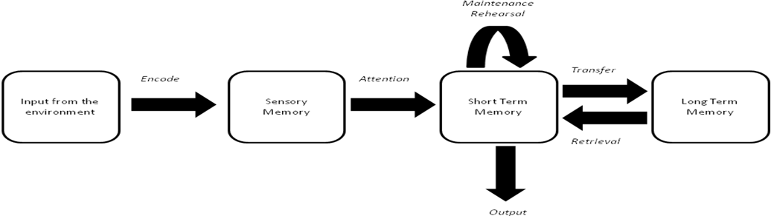
Input from the Environment
- Without an input, there is nothing to store in the memory. This input comes from the environment.
Encoding
- The input needs to be encoded (made sense of) so that is can be put into the memory stores.
Sensory Store
- This store holds all the information that is immediately around us (e.g. sights, sounds, smells).
- It has a very limited duration but a very large capacity.
Attention
- If we do not pay attention to something, the information in the sensory store decays. If we do pay attention, it is passed to the short term memory (STM).
STM
Must Know  - The capacity of STM is 7+/- chunks.  - The duration of STM is between 10-20 seconds.  - Information will either decay (because time has run out)  - Or be displaced (there is not enough space because other information is coming in). | Could Know  - If decay or displacement happens, then the information becomes unavailable (it is gone for good).  - The duration of memory is measured in seconds. The MSM argues that the duration of memory is between 10-20 seconds. For example, if a person was given a piece of information but was prevented from rehearsing it, it would stay in the STM for around 15 seconds.
Maintenance Rehearsal
- To keep information is the STM, we need to keep repeating it.
Transfer
- If we rehearse information for about 30 seconds, it should transfer to the long term memory (LTM).
LTM
- The LTM has unlimited capacity and unlimited duration.
Retrieval
- Retrieval is not always possible (i.e. when information is inaccessible). However, it may be retrieved at a later date or when we are given a cue to remember it.
Forgetting
Displacement  Displacement occurs when a memory store runs out of space because it is overloaded. For example if a waiter is given a long list of drinks to remember, the earlier ones may be ‘shunted out’ by any new ones entering the STM. | Decay  Decay occurs over time when a piece of information has not been rehearsed at all or not enough, it fades away. Decay happens in a matter of seconds in the STM. Some psychologists believe it can also occur in LTM. Decay occurs when we don’t use a piece of information enough.
NOTE: For a 10 mark answer on the MSM, you must focus on the STORAGE (Sensory Memory, STM & LTM for 5 AO1 marks)
LT2 Core Theory: The Behaviourist Theory (AO1)
- Behaviourists believe that behaviours are learnt rather than natural. Therefore they believe that people learn to be phobic rather than are born phobic.
Classical Conditioning | Operant Conditioning
- Classical conditioning is learning by association and is when people learn to associate a particular response with a particular stimulus.  - They believe phobias are the result of a negative experience with the feared object, context or activity.  Key terms:  Unconditioned response (UCR)- A response which is natural and does not need to be learnt.  Unconditioned stimulus (UCS)- Something that triggers a natural (unconditioned) response.  Neutral stimulus (NS)- Something that would not normally trigger a reaction.  Conditioned stimulus (CS)- Something that triggers a learnt response; something we have to be conditioned to respond to.  Conditioned response (CR)- A response which has been learnt (or conditioned) through association.  UCS UCR  (Sting) (Fear)  UCS + NS UCR (association and repetition)  (Sting) (Bee) (Fear)  CS CR  (Bee) (Fear)  Explaining a Phobia of Bees  Being stung (unconditioned stimulus) may cause a fear response (unconditioned response) because it could cause you pain. If it is a bee that stings you, then you could associate the stinging with the actual bee. Before this event a bee might see quite harmless (neutral stimulus). Through repetition and association the bee becomes a conditioned stimulus because it triggers a conditioned response (fear). | - Operant conditioning is also used by Behaviourists to explain phobias.  - It is learning by consequences. If the consequences are rewarding we learn to do them again but if they are negative we tend not to repeat the action.  - This can explain why phobias continue and we do not lose them.  - For example, why do people not learn that not every bee is going to sting them? We only learn this when we face our fears. Many do not face their fears because avoiding the fear is rewarding, so they keep on avoiding the object or situation. If they do try to face their fear it will result in anxiety. As anxiety is punishing people won’t want to face their fear again.  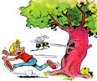  NOTE: You only need to learn the italic writing for the exam. The rest is to help you understand the theory.
The behaviourist principles of classical conditioning can be used to explain the onset of a phobia, and then the behaviourist principles of operant conditioning can be used to explain why it continues.

