How to be a man:
tips from 1930s agony aunts

While young ladies may have been daydreaming of handsome film stars such as Cary Grant, pictured here kissing the cheek of Ingrid Bergman in a publicity still for the 1946 film ‘Notorious’, agony aunts were keen to bring them back down to earth.

Ellie Cawthorne: (History Extra, BBC History Magazine, 2018)

“ANNOUNCING ANN TEMPLEAND THE HUMAN CASEBOOK. Through its intimate service, the Human Casebook is intended to bring success and happiness to all readers with personal problems and troubles, great or small, real or imaginary. Cases of the most general interest will be dealt with daily, the necessary anonymity being employed.”

This advert, appearing in the Daily Mail on 6 February 1936, signalled the beginning of a new and revolutionary addition to the British daily papers; the agony aunt column. For the first time, newspaper readers were invited to offer up their private and personal issues for public consumption. Many obliged, filling the daily columns with a wide variety of emotional issues, banal problems and moral dilemmas, in letters that ranged from enquiries over etiquette to advice on adulterous spouses.

We now associate agony aunt columns with women’s magazines. During the 1930s, however, many of the ‘problems’ published in the pages regarded, or were written by, men. By answering letters about scruffily dressed boyfriends, male cooking and family relationships, agony aunts instructed men on the correct ways to behave in interwar Britain. In doing so, they were not just advising the individuals who wrote in, but setting standards for the whole nation. Here’s some of what they had to say about being a man…

There’s no need to be handsome
“Good looks are worthless if the character behind them does not back them up”, the Daily Mirror’s agony aunt Dorothy Dix warned her readers. While young ladies may have been daydreaming of film stars such as Clarke Gable or Cary Grant, agony aunts were keen to bring them back down to earth, reminding them that good looks should be last on the list for any woman looking for love. What’s more, they even suggested that the best looking men were often not to be trusted, imparting the wisdom that “the most handsome man is often the biggest scoundrel”.
Perhaps by their very nature as problem pages, agony aunt columns revealed that many men in 1930s Britain had serious insecurities about the way they looked. Columnists published a multitude of letters from men worried about their appearance; from a man “afraid of the consequences” of his hair turning white, to one who was “terribly hurt” by girls refusing to dance with him due to his “unsightly protruding ears”.

The agony aunts were sure to comfort men like these by telling them that physical appearance was not an important part of a man’s desirability. They instead reassured them that a “plain man can always catch up by manner and personality” and “the ugly man with a nice smile is proverbially popular”.

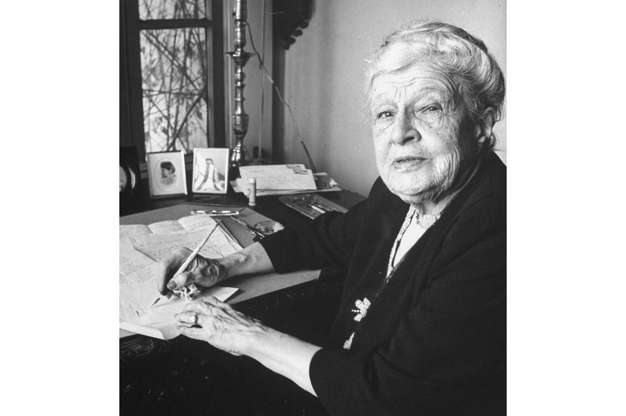
Agony aunt Dorothy Dix, c1946.

Be sure to smarten up

While men may not have been able to help their protruding ears or greying hair, they could improve their appearance in other ways, and were expected to do so. Agony columnists deemed dress, grooming and hygiene to be incredibly important. Clothing was seen as a clear statement of identity – it provided a vehicle through which a man could convey his character to the outside world. The cut of his suit or the way he styled his hair were seen as tell-tale signs of his class, character and even morals.

In a typical letter from 1938, one young woman wrote to the Mirror despairing of a fiancé who visited her “unshaved, in need of a shoeshine, a clean collar, fresh linen and to have his clothes brushed… even when we are going out with friends who are always well groomed”. The man in question was given short shrift from Dorothy Dix, who told her female correspondent in no uncertain terms to break off the engagement immediately.

While this may seem like a ridiculously over-dramatic reaction to sloppy dressing, Dix backed up her advice with pragmatic, if unforgiving, reasoning. Clearly taking dress as a clear indicator of character, she firstly argued that “any woman would soon cease to love a slovenly man”. Her reaction reveals that dress was integral to a man being taken seriously, professionally as well as romantically – and in a time when men were expected to be the breadwinners the two were closely linked.

She condemned the poorly-dressed man as a potential husband, arguing that “a man who looks like a tramp would be predestined and fore-ordained to make a failure in his profession… no employer would ever give a job to that sort of man”.

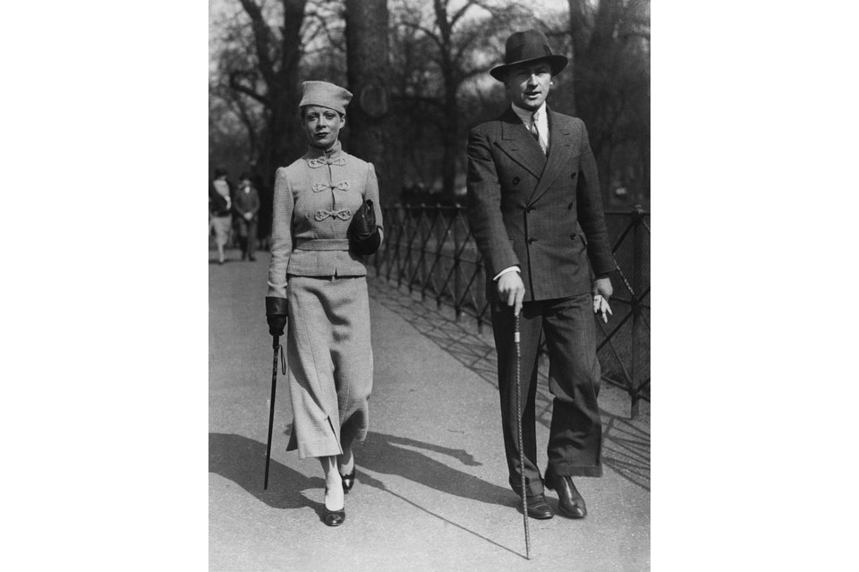

A fashionable couple strolling in Hyde Park, London, 22 March 1936

Make sure you’re reliable with money

As Britain was struck a devastating financial blow by the Great Depression, the nation plunged into a period of economic uncertainty and high unemployment during the 1930s. Money troubles were one of the most common sources of letters to the problem pages, and in this turbulent time, when men were expected to be the breadwinners, a man’s ability to support himself and provide for his family was of the upmost importance.

Young men were discouraged from relying upon financial support from others by agony aunts, and instead advised to “work and save until you can start on your own”. Any grown men who were not deemed to be assuming proper financial responsibility received short shrift from the columnists, and were condemned as the “most exasperating of human beings”.

In a period when the majority of married women were forced to be financially dependent on their spouse, girls risked their entire financial futures in their choice of husband, and the often columnists reiterated this fact. It was not necessarily huge wealth that made a man admirable or desirable, but his sensible use of the money that he had. Dorothy Dix suggested that any girl wishing to marry should do a mental questionnaire of “how much money he makes, what his chances of success in business are, and whether he is a waster or a saver”.

The agony aunts saw financial stability as a minimum requirement for a suitable husband, without which marriage was foolhardy. One woman considering marrying a penniless man who hadn’t worked for six years and was inclined to drink, was informed she had “lost every vestige of common sense to even consider it”. A classic piece of wisdom oft-repeated by the columnists was that “no matter what other charm a man may have, he is a poor makeshift of a husband if he cannot give his wife a comfortable living”. Readers were reminded that if a woman married for stability rather than romance, although she may be “starved emotionally,” she would “at least be sure of her daily beef and potatoes”.

Another message columnists reiterated time and again was that a man should never take, or even borrow, money from his sweetheart. “There is something deadly in money when it passes from a woman’s hand to a man’s” readers were warned. Men who ignored this advice exposed themselves to wrath and indignation from the columnists. One well educated man borrowing money from his sweetheart was denounced as a “parasite on a poor girl”, “a cad” and a “lazy loafer” who could stoop no lower. “If he had any spark of manhood or chivalry in him,” the agony aunt stated, “he would starve before he would take a penny from her.”

But these financial obligations could place a huge amount of pressure on men. In a 1936 letter to the Mail, a man with a large family recounted that his “ever-present fear of losing my position, which carries a good salary, is wearing me down. I brood over what would happen if I lost my income”. The pressure on men as sole providers could be a burden as much as a privilege.

There’s no shame in being caught in the kitchen

Although men were still expected to be the breadwinners, problem pages suggest gender roles were not quite as simple as the “man at work and woman in the kitchen” stereotype. In fact, agony aunts were keen to encourage men’s involvement in home life, and depicted the domestic setting as a calming antidote to men’s working lives. As leisure time and home ownership increased, there were more things for British men to do at home, from listening to the wireless to taking part in new masculine hobbies such as DIY.

It may seem surprising, but the problem pages often portrayed men helping with domestic tasks as admirable, masculine and even chivalric. They argued that helping out around the house was a “more manly thing to do” than “shying away from a dishcloth” or making your wife struggle home carrying heavy groceries.

Certain aspects of male domesticity were deemed not just acceptable, but modern and even fashionable. One man’s shame at being caught in a kitchen with a teacloth in his hand was dismissed as outdated “in this modern era when cooking has become a fad with men”.

Columnists advocated house-proud men as role models, reminding male readers that many famous actors, professionals and businessmen were “prouder of their performances on the gas range than they are of their achievements in art, literature or business”.

Despite this, some of the letters published in problem pages reveal that helping with household chores still proved highly problematic for many men, due to its feminine connotations. In a letter to the Daily Mirror, “Vera” admitted making the unfortunate mistake of handing her “horror-stricken” fiancé a dishcloth in front of other men. She described how he begged her never to do so again, for the fear that it “might make others think him effeminate”. Clearly for some men, helping out around the house was still a challenging concept to grapple with.

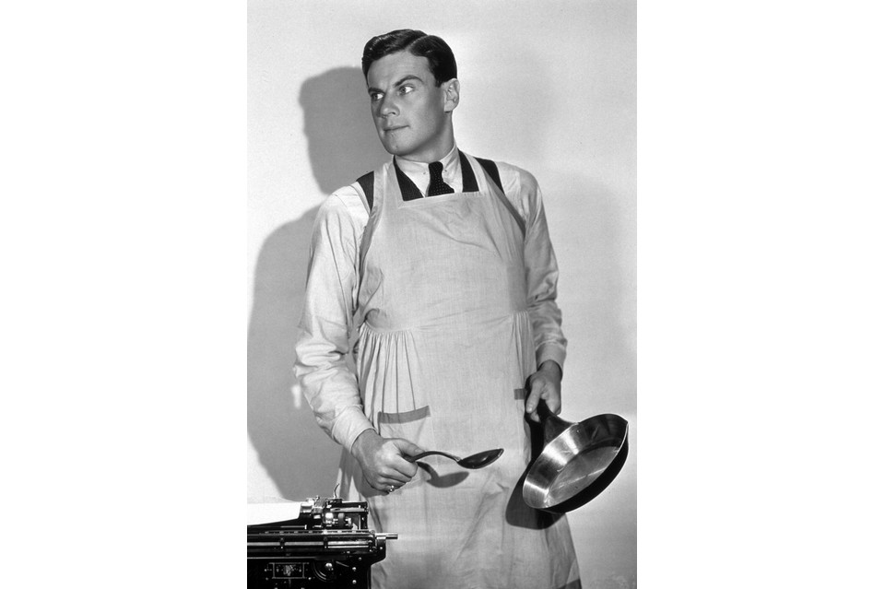

Actor Norman Foster preparing to cook in a still from the 1931 Paramount film
'Up Pops The Devil,' in which a wife supports her husband so that he can write novels.

Don’t be afraid to be a hands-on father

Between the wars, things were changing for fathers in Britain. A new appreciation of hands-on fathering was emerging, seen as a rewarding emotional experience for both parent and child. Newspapers, magazines and adverts promoted images of caring and involved fathers, while the Fathercraft Movement ran classes to educate ordinary men in parenting. Children were no longer expected to be a man’s financial obligation, but a central and enjoyable part of his emotional life.
Dorothy Dix’s column in the Mirror reflected this idea, stating that all children needed the “strong and tender hand of a father” to guide them. She encouraged male readers to foster close relationships with their children, telling them that “a good father chums with his daughter… He makes it natural that when she grows up she should discuss with him the boys who come to see her”.

Ann Temple of the Daily Mail’s Human Casebook column called a man’s desire to talk about his children’s activities “natural, and I think, rather charming”. A father’s role was seen to complement that of the mother. Temple asserted that men’s “detached views and robust methods” proved “an excellent check on a woman’s tendency to over detail” in child-rearing practices. She advised parents to work as a harmonious team and talk childrearing concerns over together.
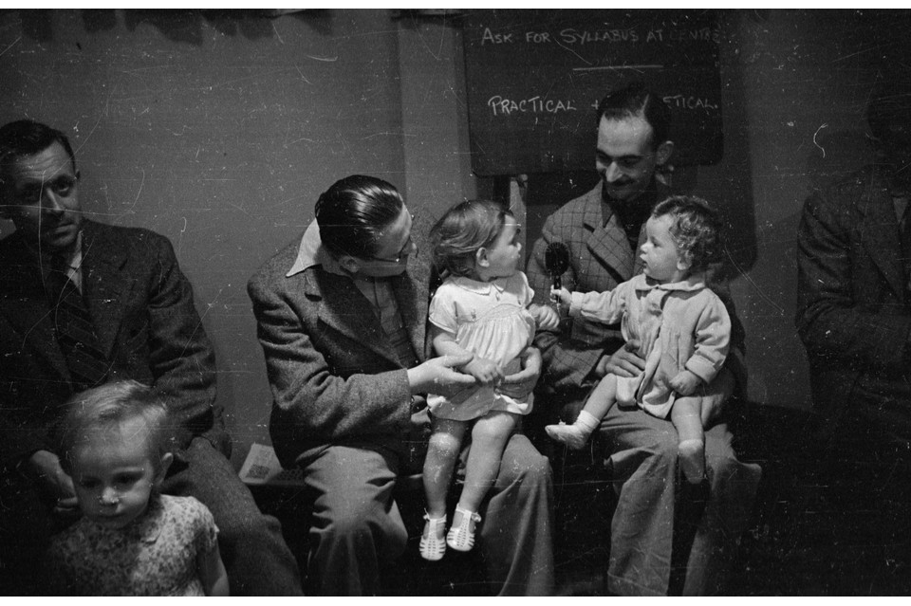
Fathers and children attending a class organised by the Mothercraft Training Society
at their centre in Kingston-on-Thames, 29 July 1939.

Countless fathers wrote in to agony aunts with questions about parenting, demonstrating that childcare was not just deemed the responsibility of mothers – it was also a pressing worry for many men. Fathers expressed concern over a huge range of issues, from their children’s diet to their daughter’s love life or teenage son’s “dance-band madness”. The struggle to maintain a good relationship with children was a recurring theme in fathers’ letters. One “perturbed” man asked how to avoid losing touch with his children, whose company he said he was dependent upon, while another who considered himself “close friends” with his son, expressed significant distress at the breakdown of their relationship.
Agony aunts painted a somewhat confusing image of the ideal man in interwar Britain. While men were progressively encouraged to be hands-on in the home and passionate as parents, at the same time they were also expected to fulfil more traditional gender roles. Letters from men reveal how difficult it could be to live up to all these conflicting expectations, and the problems they wrote in with reveal that ideas of masculinity were constantly being discussed, debated and negotiated, not just in the pages of newspapers, but also within men’s everyday lives.

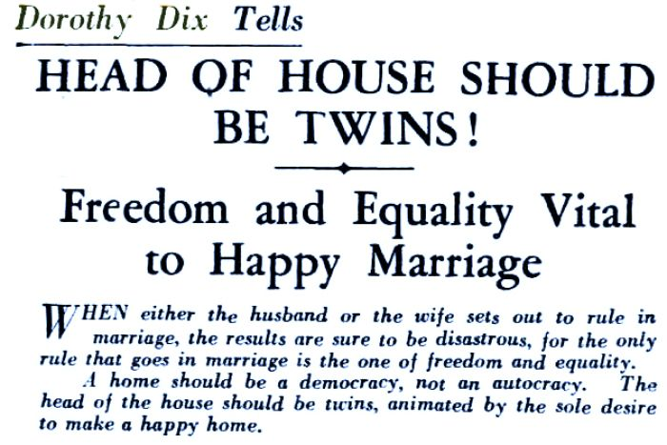
Advice on how to achieve a happy marriage from Dorothy Dix in 1931

