QUESTIONNAIRES | Evaluation Points |  | Ethical Issues | Process of Research
 | Strengths and Weaknesses |  | Right to Withdraw  The participants must be able to drop out at any time.  Can be overcome by researcher telling participants that they can leave research at any time.  Informed Consent  The participants must be told about the research before they take part and give permission to take part  Participants can sign a consent form at the start of research to say they are happy to take part and understand the conditions of the research.  Vulnerable Groups  You have to protect vulnerable people such as children or the disabled.  Gain consent from parents or guardians of vulnerable people, as well as the individuals themselves.  Protection from Harm  Participants must not be harmed in anyway during research.  Ensure participants leave the research in the same physical and psychological state they entered in  Confidentiality and Anonymity  You have to ensure that when research is published you have kept people confidential and not used their real names to protect them.  Ensure that when research is published names are changed and data is kept on a password protected computer. | 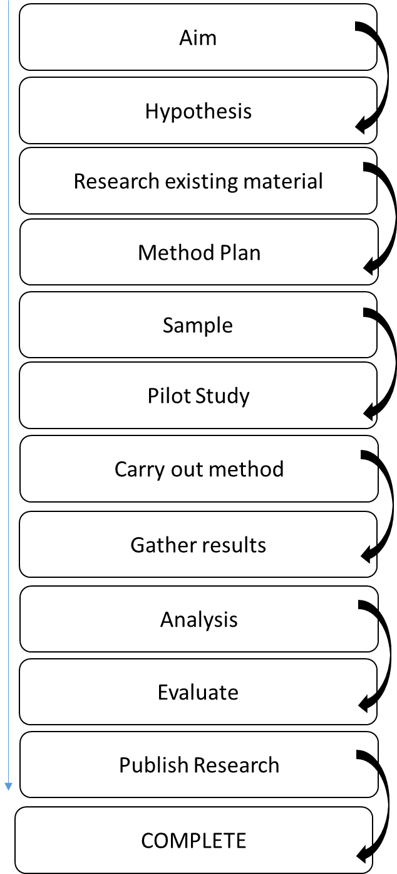
Questionnaire A method which involves asking questions, usually in a written format.  Survey A type of questionnaire used for large scale research.  Self-Report The type of questionnaire where the respondent fills it out by themselves. It is normally posted to them.  Response rate The amount of responses you get back from participants.  Open Questions Questions where participants can write a free response.  Closed Questions Questions which have a set response, perhaps a YES or NO, a number or a position on a Likert scale. | Practical  Reliable  Generalisable | Validity  Rapport  Response Rate
 | Can gain response from a large number of participants. Data easy to analyse. | Can’t use with ppts who are illiterate or may not understand questions. It is easy to lie.
INTERVIEWS
Interview Schedule The list of questions a researcher asks their participants.  Structured Interviews Interviews where the interviewer sticks to the questions on the interview schedule only. A bit like a questionnaire.  Unstructured Interviews Interviews where the researcher has an idea of what they want to find out a bit, but not set questions. More like a conversation.  Semi-Structured Interviews The interviewer has a list of questions, but can go off topic if required to allow the participants to elaborate on points made.  Interviewer Bias When the characteristics of the researcher impact the answers given my participants.  Rapport Having/building a good relationship with participants.  Standardised Is the same for every single participant. This helps reliability. | Ethical  Response Rate  Valid (If unstructured) | Time consuming  Unreliable  Biased
 | Participants can open up if they want to and will give consent otherwise they wouldn’t be taking part. | The transcription of interview data takes a significant amount of time.
OBSERVATIONS
Observation A research method which involves watching social life as it happens in social groups’ natural environment and everyday life.  Overt Observation When you are honest with your participants and let them know you are watching them.  Covert Observation Observation where you go undercover, and participants are unaware you are watching them.  Participant Observation When you join in a groups life, and take part in activities as if you were one of them.  Non Participant Observation When you sit back and watch a group from a distance without getting involved.  Outsider groups Groups which are on the outside of society, like criminal groups. | Validity  Rapport  Triangulation | Unethical  Biased  Unreliable
 | When used with the other methods you can get brilliant data. | Practically and ethically very difficult.  Problems with subjectivity and ‘going native’. | Sampling
Random Sample | Like picking names out of a hat, you have a sample made up of people who are chosen at random.  All participants have an equal chance of being selected.
Systematic Sample | A sample which has a system. For example, you pick every 4th person on the sampling frame.
Quota Sample | Like stratified sampling, that representative individuals are chosen out of  a specific subgroup to be in the sample.
Snowball Sample | The method where you find one participant, and they bring along other participants  with them who are of the characteristics you need for your sample.
Opportunity Sample | The sample where you use the people who are available at the time.

Key Terms
Participant: Someone who takes part in research.
Quantitative Data: Data which has a numerical value and can be turned into statistics or put into graphs.
Qualitative Data: Data which is written in words. These may be attitudes, opinions or experiences expressed in a written format.

