The Self : Learning Table 4 Core Study : Van Houtte and Jarvis (1995)
A01: DETAILS OF CORE STUDY OF SELF
Aim: To investigate whether owning a pet as a pre-adolescent would affect your self-esteem.
Procedure: A sample of 130 students (71 boys and 59 girls aged between 8 and 13) from Illinois were selected for research based on pet ownership. The school gave permission. Participants were told what it was all about. They were offered the chance to withdraw. Participants were mainly white American.
Participants were divided into 2 groups; pet owners and non-pet owners. They were also matched on 3 aspects; marital status of their parents, socio economic status of the parents and number of siblings they had.
Questions were also asked about details of their pet. Age of pet, type of pet, duties they had in looking after it etc. Data was also collected from all participants, using questionnaires, measuring autonomy, self-concept and self-esteem, as well as attachment to the animals.
- Autonomy was measured on a 4 point scale response to such sentences as “My parents and I agree on everything”
- Self-concept measured on a 5 point scale response to adjectives, such as “I am happy”
- Self-esteem measured on a 4 point scale response to items, such as “ On the whole I am satisfied with myself”
- Attachment to pets measured on a 7 point scale response to a series of statements, such as “I consider my pet a friend”
Results:
An analysis of the data found that:
- In general higher self-esteem was reported in pet owners than in non-pet owners.
- For 11 year olds, pets were found to positively influence self-concept
- Higher autonomy was reported by all pet owners across the age groups tested

Conclusion: Pets may have the greatest impact on children’s lives as they move into adolescence. They also put forward the idea that pets can be used to help people suffering from low self-esteem, as a support for others in times of stress, and to enhance feelings of responsibility for elderly people.
The implication is that pets can offer unconditional positive regard for pet owners.

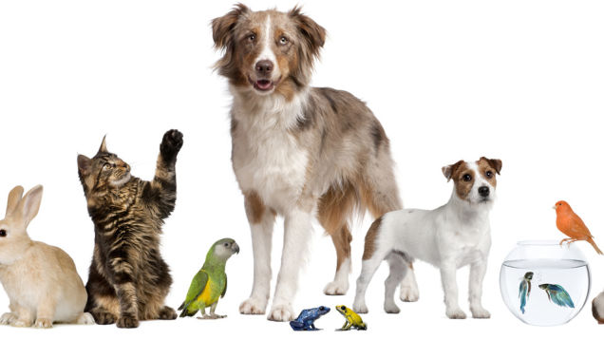

Describe = Only AO1!!

[Type a quote from the document or the summary of an interesting point. You can position the text box anywhere in the document. Use the Drawing Tools tab to change the formatting of the pull quote text box.]
[Type a quote from the document or the summary of an interesting point. You can position the text box anywhere in the document. Use the Drawing Tools tab to change the formatting of the pull quote text box.]

