The Cognitive Approach
Assumptions |  | Computer Model
- Internal mental processes can and should be studied scientifically  - As a result, they study areas neglected by behaviourists such as memory, perception and thinking  - These processes are private and so cannot be observed – they study them indirectly and make inferences about what is going on inside people’s minds based on their behaviour |  | 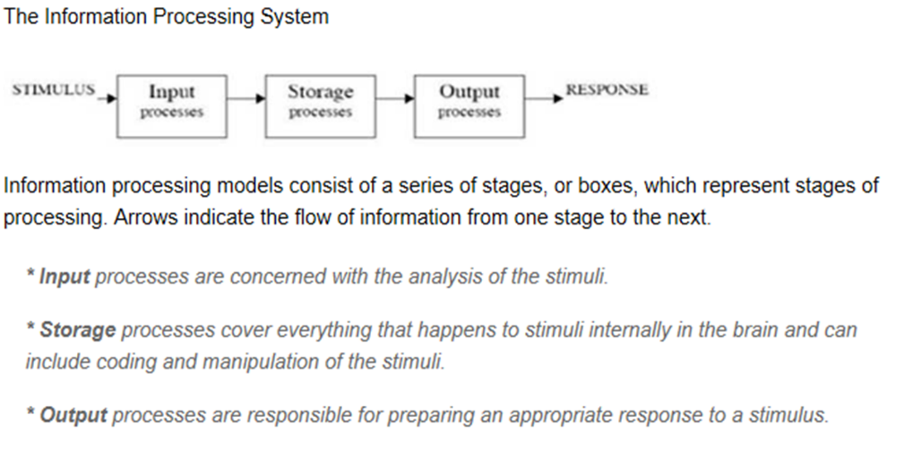
Schemas |  | The Emergence of Cognitive Neuroscience
- Schema are ‘packages’ of ideas and information developed through experience. They act as a mental framework for the interpretation of incoming information received by the cognitive system.  - For example, you have a schema for a chair – something with legs you can sit on.  - Babies are born with simple motor schema for innate behaviours such as sucking and grasping. For example, the grasping schema consists of moving a hand towards and object and shaping the hand around the object in co-ordination with visual input.  - As we get older our schema become more detailed and sophisticated.  - Schema enable us to process lots of information quickly and this is useful as a sort of short-cut that prevents us from being overwhelmed by environmental stimuli.  - However, schema may also distort our interpretations of sensory information, leading to perceptual errors. |  | - It is only in the last 20 years, with advances in brain imaging techniques such as fMRI and PET scans, that scientists have been able to systematically observe and describe the neurological basis of mental processes.  - For example, in research involving tasks that require the use of episodic and semantic memory, Tulving et al. were able to show how these different types of long-term memory may be located on opposite sides of the pre-frontal cortex. As well as this, the system in overall charge of working memory – the central executive – is thought to reside in a similar area.  - The focus of cognitive neuroscience has expanded recently to include the use of computer-generated models that are designed to ‘read’ the brain. This mapping technique is known as ‘brain fingerprinting’. One possible future application of this could be to analyse the brain wave patterns of eyewitnesses to determine whether they are lying in court!
Evaluation of the Cognitive Approach
Scientific and Objective Methods  P: One strength of the cognitive approach is that is uses highly scientific and objective methods  E: For example, Bugelsky and Alampay (1962) conducted their rat-man experiment in a lab. Two groups of participants were shown either a sequence of faces or animals before all being shown the same figure. They found that participants who saw the sequence of faces were more likely to see the final figure as a man, and those shown a sequence of animals were more likely to see the figure as a rat.  E: This is a strength because lab experiments provide high control over variables, which produces reliable, objective data. This together with the emergence of cognitive neuroscience has allowed biology and the cognitive psychology to come together.  L: Consequently, the credibility of the cognitive approach is increased. | Machine Reductionism  P: One weakness of the cognitive approach is that it suffers from machine reductionism.  E: For example, it too readily compares the human mind to the operations of a computer.  E: This is an issue because although there are similarities between the two (e.g. inputs and outputs, storage systems, the use of a central processor), it ignores the influence of human emotion and motivation on the cognitive system, and how this may affect our ability to process information. For instance, research has found that human memory may be affected by emotional factors, such as the influence of anxiety on eyewitness testimony.  L: As a result, the credibility of the cognitive approach is reduced. |  | Lacks Mundane Realism  P: One issue with the cognitive approach is that research into the cognitive approach lacks mundane realism.  E: For example, experimental studies of mental processes are often carried out using artificial stimuli (such as tests of memory involving word lists) that do not represent everyday memory experiences and therefore lacks mundane realism.  E: This is an issue because cognitive psychologists can only therefore infer mental processes from the behaviour they observe in their research. This can mean that cognitive psychology can suffer from being to abstract and theoretical in nature and may not be an accurate explanation of behaviours.  L: As a result the internal validity of the research is reduced, which in turn reduces the credibility of the cognitive approach.

