The Learning Approach: Behaviourism (AO1)
General Assumptions:
- The behaviourist approach is only interested in studying observable and measurable behaviour
- Reject introspection for being too vague and having concepts that are too difficult to measure – prefer the use of lab experiments for more control and objectivity
- Behaviourists suggest (thanks to Darwin) that basic processes that govern learning are the same in all species so they use animals as experimental subjects and generalise their findings to humans
Classical Conditioning – Pavlov’s Research  - This is where we learn through association  - Pavlov revealed that dogs could be conditioned to salivate to the sound of a bell if that sound was repeatedly presented at the same time as food  - This would produce the salivation response every time they heard the sound  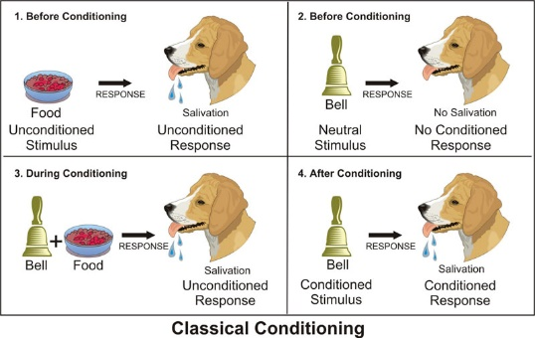  - So Pavlov was able to show how a neutral stimulus (e.g. the bell) can come to elicit a new response (conditioned response) through association |  | Operant Conditioning – Skinner’s Research  Positive reinforcement: receiving a reward when a certain behaviour is performed e.g. praise from a teacher for answering a question correctly in class  Negative reinforcement: when an animal (including humans) avoids something unpleasant e.g. when a student hands in an essay on time to avoid being told off, or tidying your room to avoid being nagged by parents  Punishment: unpleasant consequence for a behaviour e.g. being shouted at by a teacher for talking in a lesson  Positive and negative reinforcement increase the likelihood that behaviour will be repeated. Punishment decreases the likelihood that behaviour will be repeated
Evaluation of Behaviourism
Scientific Credibility  P: One strength of the Behaviourist approach is that it has high scientific credibility  E: For example, behaviourism brought language and methods of natural sciences into Psychology by studying observable behaviour in highly controlled lab settings (e.g. Pavlov’s dogs and Skinner’s rats)  E: This is a strength because it emphasises the importance of scientific processes such as objectivity and replication which are key features when defining what a science really is.  L: As a result, the credibility and status of the behaviourist approach is increased. | Real-Life-Application  P: One strength of the behaviourist approach is that it has many real-life applications  E: For example, operant conditioning has been used to develop token economy systems in prisons and psychiatric wards (where patients or prisoners are rewarded with tokens that they can exchange for goods when they behave in the desired way), and classical conditioning has been used in the treatment of phobias.  E: This is a strength because it shows that the behaviourist approach is accurate in its assumptions and that we can use these understandings to aid and better the existence of humans to allow for better lifestyles and treatments of potentially debilitating disorders.  L: As a result, the credibility of the behaviourist approach is increased |  | Mechanistic View of Behaviour  P: One weakness of the behaviourist approach is that it is reductionist.  E: For example it only considers animals, including humans, to be passive and machine-like responders to the environment, with little to no conscious insight into their behaviour.  E: This is a weakness because it fails to consider the complexities of human behaviour. Other approaches such as the social learning theory or the cognitive approach have emphasised the importance of mental events during learning. These processes, which mediate between stimulus and response, suggest that people may play a much more active role in their own learning. This means that learning theory may apply less to human than to animal behaviour.  L: Consequently the credibility of the behaviourist approach is reduced.

