Gender and Culture in Psychology: Gender Bias
Gender Bias AO1
Universality and Bias
Bias is often inevitable in research. This is despite the arguments psychologists might make to have discovered ‘facts’ about human behaviour that are ‘objective’ and ‘value free’. It also undermines psychology’s claims to universality (conclusions can be applied to everyone, anywhere, regardless of time or culture).
Gender Bias
Alpha bias = exaggerates/overestimates differences between the sexes. Such differences are typically presented as real and enduring; fixed and inevitable. They tend to devalue females in relation to men (although not always). E.g. sociobiological theory of relationship formation; it’s in the male’s interest to try to impregnate as many women as possible to increase chances of genes being passed on. For the female, the best chance of preserving her genes is healthy survival of relatively few offspring she is able to produce in her lifetime. This theory suggests that sexual promiscuity in males is genetically determined, whilst females who engage in the same behaviour is regarded as going against their ‘nature’. This exaggerates the difference between men and women.

Beta Bias= minimises/underestimates differences between men and women. This often occurs when female PPs are not included in research samples, and it is just assumed that research findings will apply to both sexes. E.g. the fight or flight response: it was once suggested that fight or flight was a universal response to a threatening situation. More recently however, Shelley Taylor et al. (2000) have suggested that female biology has evolved to inhibit the fight or flight response, shifting attention towards caring for offspring (tending) and forming defensive networks with other females (befriending).
Androcentrism
If our understanding of what counts as ‘normal’ behaviour is being drawn from research that involves all-male samples, then any behaviour that deviates from this standard is likely to be judged as ‘abnormal’, ‘inferior’ or ‘deficient’ by comparison. At best, this leads to female behaviour being misunderstood, and at worst, pathologised (taken as a sign of instability or disorder). E.g. many feminist commentators have objected to the diagnostic category pre-menstrual syndrome (PMS) on the ground that it stereotypes and trivialises female experience. Critics claim that PMS is a social construction which medicalises female emotions, especially anger, by explaining these in hormonal terms. Male anger, on the other hand is often seen as a rational response to external pressures.
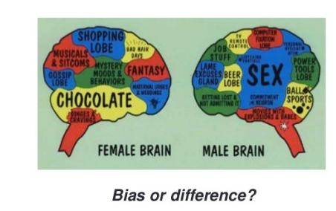
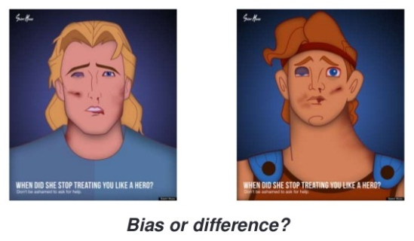

Gender Bias AO3
Implications of Gender Bias  P: One issue with gender bias in research is that there may be negative implications.  E: For example, it may provide scientific ‘justification’ to deny women opportunities within the wider society or workplace.  E: This is an issue because this gender-biased research may create misleading assumptions about female behaviour, fail to change negative stereotypes and validate discriminatory practices. This in turn means damaging consequences for women which affects their lives and prospects (e.g. women are twice as likely to be diagnosed with depression than men).  L: Overall, gender bias in not just therefore a methodological problem, but also a real threat to the welfare, happiness and progression of women. | Sexism within research Process  P: One further weakness of gender-biased research is that it may be subject to sexism as well as bias.  E: For example, there is a lack of women appointed at senior research level meaning that their concerns over gender bias within research may not be heard.  E: this is an issue because currently males researchers are therefore more likely to have their work published that includes gender differences rather than those who do not. Also, the lab experiment may disadvantage women as it is also usually a male researcher, who has the power to label the woman unreasonable or unable to complete a complex task.  L: As a result, psychology as a whole may be guilty of supporting a form of institutional sexism that creates bias in theory and in research. | Reflexivity  P: One strength of gender bias in psychological research is that it there is reflexivity in this.  E: For example, rather than seeing bias as a problem that may threaten objectivity of research, researchers embrace it a crucial aspect of the research process in general.  E: This is a strength because modern researchers are beginning to realise their own values and assumptions actually have an effect on their research e.g. Dambrin and Lambert (2008) included reflection on how their gender-related experiences influence their reading of events.  L: This is a strength because reflexivity leads to greater awareness of the role of personal biases in shaping research, meaning that gender-bias in research can be deemed as important, rather than a hindrance. | Alternative Methods of Research  P: One weakness of gender bias in research is that its existence and necessity has been questioned.  E: For example, Feminist psychologists such as Worrell (1992) have suggested more effective, less biased ways of researching by using strict criteria.  E: This is an issue because the research done by these psychologists has still shown support for theory but has eliminated the effect of gender bias. For example they show that women should be studied in meaningful real-life contexts, and genuinely participate in the research. Diversity in groups of women should be examined, not just differences between men and women, as well as emphasis on qualitative, collaborative data collection methods rather than numerical, quantitative methods.  L: As a result, we can see that gender bias is arguably unnecessary and can be dealt with much more effectively than it is currently.

