Endogenous Pacemakers and Exogenous Zeitgebers
Endogenous Pacemakers and Exogenous Zeitgebers AO1
Endogenous Pacemakers and the Sleep/Wake Cycle
The Suprachiasmatic Nucleus (SCN)
- Tiny bundle of nerve cells in the hypothalamus
- Primary endogenous pacemaker in most mammals
- Maintains circadian rhythms
- Nerve fibres connected to the eye cross at the optic chiasm on their way to the visual area of the cerebral cortex
- SCN = just above optic chiasm
- Receives info about light directly from the optic chiasm
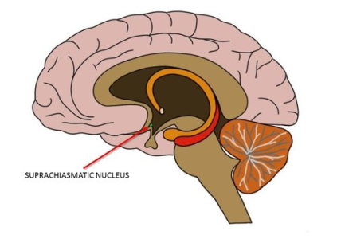
- Happens even when eyes are closed, so our bio. Clock can adjust to daylight
Animal Studies and the SCN
DeCoursey et al (2000):
- DeCoursey et al (2000) destroyed SCN connections in 30 chipmunks
- Returned them to natural habitat and observed for 80 days
- Sleep/wake cycle had disappeared and many had been killed by predators (because they were awake and vulnerable to attack when they should have been asleep)
Ralph et al (1990):
- Ralph et al (1990) bred ‘mutant’ hamsters with a 20 hr sleep/wake cycle
- When SCN cells from foetal tissue of mutant hamsters were transplanted into the brains of normal hamsters, the cycle of the second group was 20 hrs too
The Pineal Gland and Melatonin
- SCN passes info on day length and light to the pineal gland
- During the night, the pineal gland produces melatonin (chemical that induces sleep, it is inhibited when you’re awake)

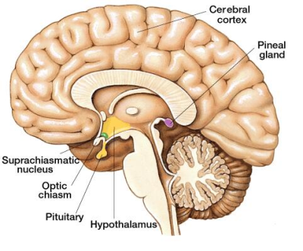
Exogenous Zeitgebers and the Sleep/Wake Cycle
Light
- Can reset the body’s main pacemaker (SCN)
- Indirect influence on processes that control functions e.g. hormone secretion, blood circulation
- Campbell and Murphy (1998) light may be detected in skin receptor sites on the body even when not received by the eyes
- 15 PPs woken at various times and light shone on back of knees
- Researchers managed to produce a deviation in PPs usual sleep/wake cycle of 3 hrs in some cases
Social Cues
- In human infants, the initial sleep/wake cycle is random
- At 6 weeks, circadian rhythms begin
- At 16 weeks, most babies are entrained
- Schedules imposed by parents are key e.g. meal times, bedtimes
- Adapting to local times for eating and sleeping is an effective way of entraining circadian rhythms and beating jet lag (so don’t just eat because you’re hungry!)

Endogenous Pacemakers and Exogenous Zeitgebers AO3
Beyond the Master Clock  P: One weakness of the theory of the SCN in maintaining circadian rhythms such as the sleep/wake cycle is that there is contradictory evidence.  E: For example, Damiola et al (2000) demonstrated how changing feeding patterns in mice could alter the circadian cells in the liver by up to 12 hours, whilst leaving the rhythm of the SCN unaffected.  E: This is an issue because it suggests that there may be many other complex influences on the sleep/wake cycle aside from the SCN, such as these peripheral oscillators in specific organs and cells of the body.  L: As a result, the credibility of the theory of the SCN in maintaining circadian rhythms such as the sleep/wake cycle is reduced. | Ethics in Animal Studies  P: One weakness of the research into the theory of the SCN in maintaining circadian rhythms such as the sleep/wake cycle is that it is scrutinised on ethical grounds.  E: For example, in DeCoursey et al’s study the chipmunks were subject to considerable harm, and subsequent risk, when they were returned to their natural habitat.  E: This is a weakness because it is a very subjective debate as to whether inflicting this pain and suffering is worth the results gathered from research such as this.  L: As a result, the appropriateness and ethics of research supporting the theory of the SCN in maintaining circadian rhythms such as the sleep/wake cycle is questioned. | Influence of Exogenous Zeitgebers may be Overstated  P: One weakness of the theory of exogenous zeitgebers in maintaining circadian rhythms such as the sleep/wake cycle is that there is contradictory evidence.  E: For example, Miles et al (1977) recounted an incident of a young man who was born blind, with a circadian rhythm of 24.9 hours. Despite exposure to social cues, his sleep/wake cycle could not be adjusted and consequently he had to take sedatives at night and stimulants in the morning to keep pace with the 24 hour world. Similarly, individuals who live in Arctice regions, where the sun does not set in summer months, showed normal sleep patterns despite prolonged exposure to light.  E: This is a weakness because both of these examples suggest that there are occasions when exogenous zeitgebers may have little bearing on our internal rhythm, which is contrary to what the theory states.  L: As a result the explanatory power of the theory of exogenous zeitgebers in maintaining circadian rhythms such as the sleep/wake cycle is reduced. | Methodological Issues  P: One issue with research into the theory of exogenous zeitgebers in maintaining circadian rhythms such as the sleep/wake cycle is that there is yet to be further supportive research conducted.  E: For example, the findings of Campbell and Murphy’s study have yet to be replicated. Other psychologists have been critical of the manner in which the study was conducted and have suggested that there may have been some limited light exposure to the PP’s eyes.  E: This is an issue because without replication, we cannot be sure of the reliability of the research and therefore it cannot entirely provide supportive evidence for the theory of the influence of the particular variable of light on the sleep/wake cycle.  L: As a result the theory of exogenous zeitgebers in maintaining circadian rhythms such as the sleep/wake cycle is reduced.

