Learning table 5: Applications of research into Atypical Behaviour
The reason why psychologists want to explain why atypical behaviours happen is so that they can try to control them. Phobias can be counter-conditioned which is where behaviour therapy comes into play.
Flooding  - Clients are immersed in their fear.  - They face their fears full-on.  - For example, a person with a fear of flying may be taken up in an aircraft and flown around for 30 minutes.  - The theory is that the clients will form a new association between the feared object or situation and overcome their phobia.  - Initially the client will be full of fear (heart racing, sweating, feeling sick)because they are in their most feared situation  - However, a body cannot maintain such a high level of arousal (our heart rate has to slow down or we can kill ourselves) so eventually the increase in the body’s responses has to subside.  - As the client calms down they are still in their feared situation yet they are feeling more relaxed.  - Now they should form a new association e.g feeling relief when flying in a plane. | Systematic desensitisation  - This is done by forming a hierarchy of fear, involving the conditioned stimulus (e.g. a spider), that are ranked from least fearful to most fearful.  - The patient works their way up starting at the least unpleasant and practicing their relaxation technique as they go (e.g breathing techniques).  - When they feel comfortable with this (they are no longer afraid) they move on to the next stage in the hierarchy.  - Thus, for example, a spider phobic might regard one small, stationary spider 5 meters away as only modestly threatening, but a large, rapidly moving spider 1 meter away as highly threatening. The client reaches a state of deep relaxation, and is then asked to imagine (or is confronted by) the least threatening situation in the anxiety hierarchy.  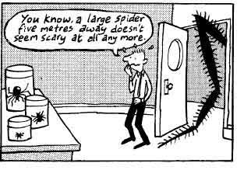  - The client repeatedly imagines (or is confronted by) this situation until it fails to evoke any anxiety. This process is repeated while working through all of the situations in the anxiety hierarchy until the most anxiety-provoking. | Implosion therapy  - Implosion therapy is similar to flooding in the sense that it gets clients to face their worst fears.  - However, instead of being unethical and putting people in their worst scenario they have to imagine it instead.  - Clients are asked to simply imagine their worst fears. Eventually the client forms a new association with their fear (e.g relaxed whilst imagining being in an aeroplane).

