Applications of Research into Sex and Gender
Research into sex and gender is important for real-life situations. It is crucial that psychologists discover which gender differences, if any, children are born with. The point is that if males and females naturally have different strengths or abilities then there is little we can do about this. However, if males and females are born more or less the same, then they can potentially achieve the same kinds of things.
- Equal Opportunities in Education
Nature or Nurture?  There is still a lot of debate about how different females and males are and whether this is due to nature (our biology) or nurture (our environment). This debate is particularly relevant to equal opportunities for the sexes. If males and females are essentially the same, then we just need to give them the same opportunities to succeed.  However, if one sex has a natural advantage over another, we may need to use positive discrimination to create better opportunities for the disadvantaged sex. For example, what if boys naturally struggle with reading and writing more than girls do? It may be that schools need to put more resources into helping boys with their literacy. Similarly, if girls struggle more with mathematical tasks, then schools may need to put more resources into helping them.  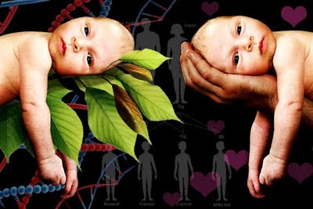 | The Gender Gap  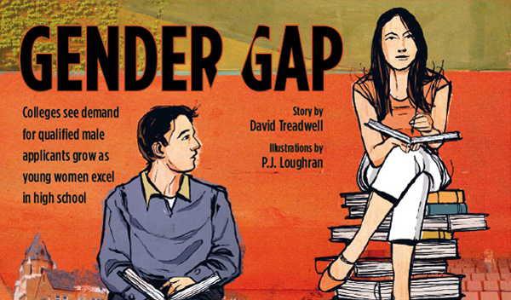  A lot of evidence shows there are very few natural differences between females’ and males’ abilities. Despite this, females are doing significantly better than males in both GCSEs and A-Levels. This is sometimes known as ‘the gender gap’.  How do we explain the gender gap in education? If females are performing better than males in education yet they are not naturally better, then what is it down to? A lot of psychologists would argue that it must be to do with socialisation. In other words, we bring up girls and teach girls to be more successful at school. Interestingly, before the 1980s, it was the other way round in the UK. Males used to do much better than females in secondary education and beyond. Is this because girls were not encouraged to be successful in education? Or does the school curriculum now take into account girls’ natural interests and abilities more than it used to? | Differences between Males and Females  There is some evidence of natural differences between males and females. Some research has found that males have better visual-spatial skills than females. This would suggest that teachers need to spend more time developing these skills in female students to give them the same opportunities as males. For example, females may need more instruction in map reading skills in Geography, more support in doing transformation in Maths or more coaching in hand-eye coordination in PE.    Meanwhile there is reliable evidence to suggest that females are stronger verbally. This means that teachers may need to find other ways of testing and assessing male students, besides getting them to talk about what they know.
NOTE: You only need to learn the right hand column for a question on this – the rest is information to help you understand the application.

