Applications of Research into Memory: Memory Aids
Note: You should use this information if you get a question about real life application of research into memory.
- Use of Cues  - Cues work on the assumption that ‘lost’ information is just inaccessible and can be retrieved.  - Cues help to trigger and therefore access lost information.  - Cues can trigger memories through any of the senses for example, the smell of Plastercine may remind someone of an event from their childhood.  - Another real life example of the use of cue to aid memory is police reconstruction of a crime. This can aid both visual and verbal cues. By recreating the context of a crime, police hope to trigger witnesses’ memories.  - You could even use cues to aid your memory during revision. For example, a student could wear a specific perfume/aftershave when revising a certain subject, if they then wore that scent on the day of the exam, it would act as a cue to trigger retrieving information for the exam. |  | 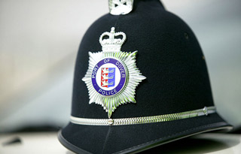
- Mnemonics - Acrostics  - The work mnemonic is an umbrella term for any memory aid.  - An acrostic is a sentence/phrase of words that begin with the same letter as the list of words you would like to remember.  - For example, Richard of York Gave Battle In Vain is an acrostic for remember the order of the colours of the rainbow. (Red, Orange, Yellow, Green, Blue, Indigo, Violet). | - Mind Mapping  - Mind mappings are another way in which to aid your memory.  - If constructed correctly, there are supposed to improve recall because they are organised in the same way in which memory is organised. |  | - Use of Imagery  - If you have to learn and remember written information it has been found that relating it to images (or pictures) will help.  - Not only does it give the information more meaning, it also doubles you chances of remembering it (i.e. having a word and an image to recall).
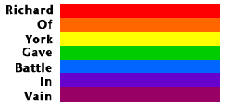 | 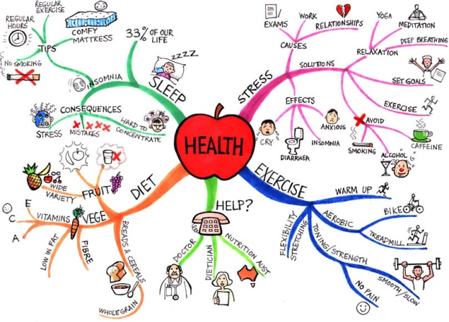 |  | 