Social Psychology: NVC Learning table 5 : Application of research
APPLICATION OF RESEARCH INTO NVC – Social Skills Training (SST):
The study of NVC has led to a better understanding of how people interact socially and has helped to identify what makes people better in dealing with others. SST involves giving individuals the skills to cope in situations they struggle to cope in. It can help people to understand other peoples body language and to be able to ‘speak’ appropriately using their own body language.
The 4 mechanisms of Social Skills Training : | Examples of who might benefit from SST
After identifying what the problem is, SST uses 4 main mechanisms to the client:  1. Modelling - The trainer demonstrates or acts out the correct behaviour, for example good eye contact, whilst the client watches.  2. Practice – The client is encouraged to imitate the trainer, and role play is used to build up the desired behaviour  3. Feedback – The trainer comments on the clients practice performance, sometimes using a video of the practice behaviour and good social skills are reinforced.  4. Homework - The client is encouraged to transfer the newly acquired skills to real life and to as many real people as possible and report back to the trainer.  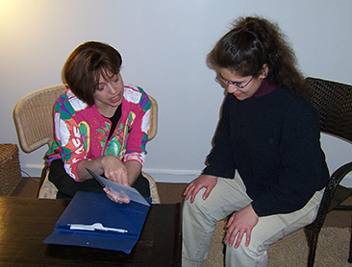 | 1. Rehabilitation of offenders  SST has been used in rehabilitating offenders by teaching offenders new ways of communicating (including NVC) so they will be able to manage difficult situations more effectively in the future. For example their risk of re-offending may be reduced if they can avoid getting into conflict with others.  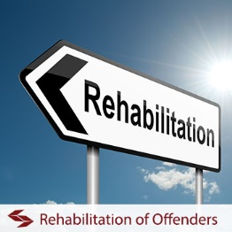
2. People who work in situations of potential conflict

SST is also widely used for training employees in professions that require conflict management, e.g. the police force, customer services, social services, education and the health service.

