The Self: Alternative Theory
Eysenck’s Trait Theory
Rather than believing personality and the self are influenced by others and the environment (nurture), Eysenck believed that personality has:
- A genetic basis – we’ve been born that way
- A biological explanation – our personality is shaped by the activity of part of the mid-brain called the reticular activating system which activates higher parts of the brain
This alternative ‘trait theory’ provides the following:
- A more scientific approach to try and measure personality more reliably
- Make more generalisations about people by recognising that we have traits in common with others
- Believe that our personality is more a product of genes than how others respond to us
Eysenck studied 700 soldiers who had been psychologically damaged during the Second World War, and he suggested that there are just four basic dimensions of personality:
- Extraversion: the degree to which someone is outgoing and sociable
- Introversion: someone who is typically quiet and reserved
- Neuroticism: being anxious or moody, worried all the time
- Stability: being emotionally stable
Extraversion  If you see someone being very lively and energetic at a school disco it could just be a one-off, but if that person is always the life and soul of a party, and you know they are lively and outgoing at work as well as at parties, you will guess that they are showing the basic extraversion trait generally | Neuroticism  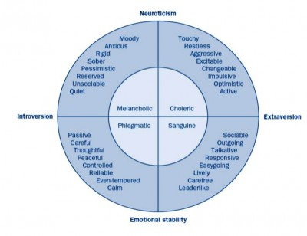  If you know someone who is a worrier, who always says ‘but what if..?’ to any new idea or plan, who gets so worked up about the situations as to make themselves sick, or who always expects things to go wrong, then that person is showing all the traits of a neurotic personality.

