Non-Verbal Communication: Alternative Theory
The Evolutionary Theory
Rather than believing that NVC is learned (or nurtured) it would seem that it is more to do with human biology (nature).
Instinct  Evolutionary theory argues that human beings, and other animals are governed by instinct. It is natural and instinctive for animals to want to live long enough to pass on their genes. Therefore over time, humans and other animals have evolved to pass on behaviours that help them to survive and reproduce. |  | Universal Non-verbal communication  Some human behaviour is universal (i.e. it is found all over the world in all societies). This is evidence to suggest that certain forms of NVC have evolved to help survival and/or reproduction. This is particularly important in pre-historic times when humans had not yet developed the capacity to communicate with words.
 |  | 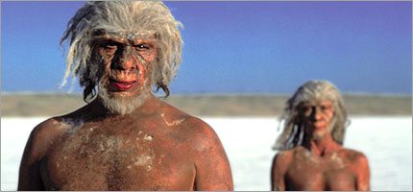
Evidence for the evolutionary approach can be seen when looking at universal NVC, this can easily be linked to either survival or reproduction.
Survival |  | Reproduction
Feature of Evolution | Examples of NVC | Feature of Evolution | Examples of NVC
Warding off potential enemies of threats | - Baring your teeth  - Squaring your shoulders  - Increased eye contact | Appearing more attractive | - Men: ‘puffing out’ their chests  - Women: placing hands on hips  - Smiling
Reducing Conflict | - Avoiding eye contact  - Backing away  - Raising an open hand to them | Allowing someone to flirt with you | - Widening of eyes  - Returning a smile  - Open gesture (i.e. no arms folded).

