Learning Table 3: Alternative Theory
Vygotsky’s Theory of Cognitive Development
- Cultural Influences
Vygotsky argued that children are born with considerable thinking abilities, but their cognitive development takes place within their culture. The origin of cognitive development does not lie in biological maturation but in social and cultural influences.
- Cultural Tools
A key point is that the child picks up tools for thinking (e.g. language, writing, number systems and ideas from Science) and these are developed around them in their home. He called them cultural tools. He believed that our culture teaches us how to think as well as what to think.
- The Apprentice
Piaget regarded the child as a ‘scientist’, following an inbuilt predetermined path of discovery and thinking. Vygotsky, on the other hand, regarded the child as an ‘apprentice’ – someone who works with a skilled person to learn their trade. So, for Vygotsky the developing child is helped forward in its thinking by the people around them, who have already become thinkers. In other words ‘we become ourselves through others.’
- The Zone of Proximal Development & Scaffolding  Vygotsky claims that everyone is born with their own potential for becoming a fully-fledged thinking human being, and that people around them can help them reach their potential. He called this the zone of proximal development (ZPD). This refers to the gap between where we are currently and where we can move to with the help of others around us. An example might be a child who has been given a construction kit as a birthday present, and who can only make it up with the help of a parent or older sibling. The word that is used for this type of learning is called scaffolding, learning through others. (Scaffolding is a support framework to allow the developing child to get on safely with their learning and thinking). | 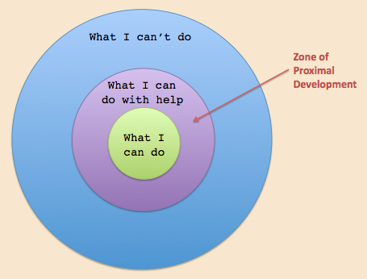
- Individual Pace
For Vygotsky, everyone’s cognitive development happens at an individual pace, helped on by significant people around them in their culture (people at home, friends, teachers and even the television). This differs from Piaget’s view, which assumed that cognitive development just progresses naturally regardless of who is around.

