Criminal Behaviour: Alternative Theory
Social Learning Theory
Social Learning Theory argues that criminal behaviour is just as likely to be learnt as inherited.
Basic Assumptions
- The Social Learning Theory argues that criminal behaviour could be the result if observing and imitating others.
- For example, if a child sees his older brother threatening someone with a knife and getting away with their belongings, the younger brother may be motivated to copy him.
- However, we do not imitate everyone we observe. Individuals imitate their role models. These are people who individuals admire and respect, and want to be like.
- Social Learning Theory states that we look towards our role models to see how we should behave.
Vicarious Reinforcement | 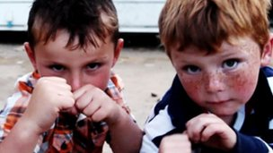  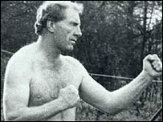
- Individuals are more likely to imitate behaviours that they see being rewarded.
- An individual is not directly reinforced themselves, but they see others being rewarded .
- On this basis they think ‘If I do so and so, I will be rewarded too.’
- For example, if a child sees her father getting respect and attention after he has beaten someone up, she may be motivated to copy him and go out and fight other children. If she is directly reinforced (rewarded) after this, then she is even more likely to continue with the behaviour.

