Secularisation: Wilson argues that secularisation is the process whereby religion loses its influence over the various spheres of social life
LEARNING TABLE 9 – SECULARISATION
Explanations as to why secularisation might be happening:  - Expansion of secondary and higher education makes a better informed population, meaning that young people are less likely to believe in spiritual explanations of the world that are not based on evidence.  - Decline in close knit communities with the rise of urbanisation and re-housing programmes. This means people are no longer socialised into going to church from family members and close friends  - The privatisation of modern families means that people look for answer within themselves rather than external forces. If a child needs to be disciplined parents will use the naughty step rather then take them to confession.  - The end of Sunday as a day of rest. Without a holy day people no longer have the time to worship formally. Instead they are working, shopping or spending much needed time with their family.  - The acceptance of scientific explanations over religious explanations for explaining core human questions (why am I here? Where does the world come from?) |  |  |  | 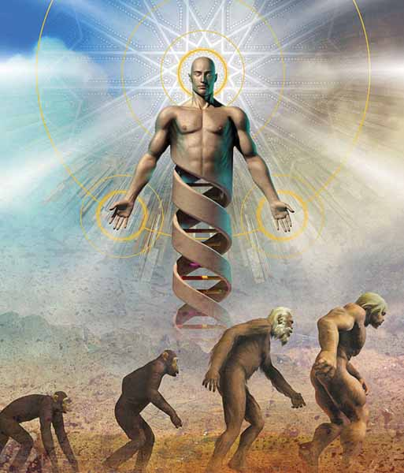
 | Britain is less religious therefore secularisation is occurring |  | Britain is still religious therefore secularisation is not occurring
Theoretical framework | - Weber argues that religion was at its most powerful when creating the spirit of capitalism and kick starting the industrial revolution. Weber then predicted that industrial capitalism would turn into technological capitalism and religious explanations would be wiped away by scientific discovery. Weber went on to argue that secularisation was an inevitable product of capitalism as the desire to maximise profit would only be possible through technological advances rather than religious influence. |  | - Postmodernists would argue that religion will always have a function in modern society. Religion will continue to be a guide at times of doubt as individual members of society have to make swift moral judgements using a variety of sources of information (reflexity).  - Marxists/functionalists would argue that religion still plays an important function in society. Marxists state that religion operates as the opium of the masses. Functionalists would argue that religion creates a collective consciousness that provides social solidarity.
Practise:  Has the amount of religious practise reduced? | - Official statistics can be used to show that religion is losing influence over British people. Between 1998 and 2005 the attendance at catholic churches dropped by 27% and Anglican churches dropped by 11%. Showing there is empirical support for the argument that secularisation is occurring in modern Britain.  - Statistics also show that christenings and baptism are in decline. In 1900 67% of children were baptised this had dropped to 27% in 1993. This shows there is further empirical support for secularisation occurring in modern Britain. |  | - Davie (1994) argues that using statistics to measure secularisation only paints a partial of view of secularisation in modern Britain. Not attending church does not mean that people have become less religious rather changed the way they express their religiosity. In this respect religion has undergone a process of individuation.  - There are methodological problems with using a secondary source of data to show religion is declining in Britain. Sociologists have been critical of historical data. Victorian membership figures are neither valid nor reliable by today's standards. This suggests that the empirical data may lack reliability and validity.
Belief:  Has religious belief changed or decreased | Pluralism – An increase in the types of religious belief in society
 | - Bruce argues that pluralism has led to an increase in NRMs, some of these NRMs can only considered as religious in a loose sense. For example Raelians beliefs of free love would be rejected by most religious groups.  - Statistics support the view that pluralism is occurring by an increase in the popularity of NRMS and NAMs Brierley (1998) uses statistics to show that new less religious movements are gaining in popularity. The fastest growing religion between 1980 and 2000 was Satanism, this clearly shows that religion has lost some of its power. |  | - Pluralism does not suggest secularisation is occurring but religious observation is changing. Bellah (1976) argues that the process of individuation has led to religion moving into the private sphere. It doesn’t matter what religious beliefs that people hold if they still have elements of spirituality attached to them it still counts as religion. The process of pluralism does not support secularisation as individuals can pick and mix their beliefs.  - Heelas’ Kendal project supports the view that increases in new religious and new age movements since the 1980s shows that people are rediscovering the importance of spirituality. A process of resacrilisation is occurring where individuals are constructing what is scared in their lives.
Organisations: Has the power of the church reduced? | Desacrilisation/rationalisation – Decline in the belief of the sacred. Myth and magic become less important in a scientifically advanced society such as modern Britain.
 | - Weber argues that science will eventually replace religion in modern society. Bruce supports this idea suggesting that scientific rationality has undermined religion. For example we take pills rather than pray when we are ill and no longer feel the need to offer sacrifices to appease gods after natural disasters.  - Berger and Luckman (1971) argue that religion requires faith whereas science is based on rational observable data. This means scientific explanations will always be more popular with the media as scientific explanations have the appearance of fact. |  | - Postmodernists argue that people have begun to mistrust science as it does not explain the fundamental questions of humanity. The big bang theory is arguably just as faith based as any religious descriptions of creation. What or who made the elements to make the big bang possible? Science struggles for answers to explain situations where there is no observable data. This suggests that religion has continuing importance in society.  - People still have the desire for magic in their lives. The popularity of Harry Potter and Lord of the rings suggests that people still have the need for supernatural explanations of life, even in highly advanced societies.
 | Disengagement/social differentiation – where the church becomes separated from the working of society
 | - Bruce argues that a process of social differentiation has occurred whereby society has become specialised and each institution has fewer functions. For example the church used to have a role in education and healthcare. These functions have been taken over by government. This means secularisation is occurring because the church’s power is reduced. |  | - Functionalists such as Parsons argue that structural differentiation is occurring, meaning that religion has become a more specialised institution. Religion still provides a specialised function of integration in society by provided an individualised framework for people to live by.
In contrast secularisation is a difficult concept to operationalise:
- Whether secularisation is occurring is dependent on the measure and definition a sociologists uses. There are no set definitions of religion or secularisation, and no way of measuring religiosity of individuals. For example the inclusivist definition of religion is includes a number of different movements such as Marxism and premier league football. The uptake and popularity of these movements cannot be measured in relation to religion. This means that all arguments related to secularisation lack reliability and validity.
- All arguments about secularisation occurring in the UK are often focussed on Christianity and therefore much of the sociology is Christo-centric. Statistics suggest that the decline of religion seems only related to Christianity in Britain.
- The Secularisation argument presumes that religion was historically powerful. Many sociologists argue that the view of a golden age of religious worship, where the church was all powerful in people’s lives, is a myth.

