 | Explanation | Reasons for differences  LT 10 – RELIGION AND SOCIAL GROUPS | However
Gender | - Woman are more religious than men: In 2005 1.8 million women in England were churchgoers, against only 1.36 million men  - Miller and Hoffman (1995) found women express a greater interest in religion, have stronger personal commitment and attend church more.  - Bruce estimates 80% of the participation of NRMs are female | Socialisation and gender role:  - Miller and Hoffman (1995) argue that women are taught to be more passive obedient and caring. These are qualities that religion values it therefore follows that women will be more religious.  - Miller and Hoffman (1995) also argue that women are more likely to work part time and so are more able to organise their time around church activities  - Davie argues that women are closer key human questions concerning birth and death and are therefore more in need of religion explanations  Women and the new age:  - Women are attracted to new age movements because they are more in tune with nature and healing. These characteristics of women mean they are more likely to join NRMs.  Compensation for deprivation:  - Women are more likely to suffer organismic deprivation, meaning they are more likely to have mental health issues and seek healing through religion.  - Women are more likely to be ethically deprived, meaning they are more likely to be morally conservative and see the world in moral decline.  - Women are more likely to be socially deprived, meaning women are more likely to be poor and look to religion for explanations of their poverty. | - Secularisation suggests that religion is becoming less influential in people’s lives. Brierley (2005) suggests that women are leaving the church at a much quicker rate then men.  - Women are increasingly able to reject traditional feminine values and make their own choices; this would clearly reduce the power of religion over women.
Ethnicity | - There is higher than average participation in most minority ethnic groups. Muslims, Hindus and non-white Christians are much more likely to see religion as important.  - Modood (1994) did find examples of lower observance in the second generation of immigrants  - 11% of white Anglicans see religion as being important in their lives opposed to 74% of Muslims. | Cultural defence:  - Bruce argues that religion operates as a sense of cultural identity in an uncertain and hostile environment. Religion becomes a basis for community solidarity that preserves culture and language. For example Pentecostalism was founded as a result of the racism young Afro-Caribbean immigrants in the mid sixties.  Cultural transition:  - Religion can help to ease the transitions between cultures at times of immigration. Herberg argues that the high levels of religious participation in the USA are a result of its ‘cultural melting pot’ origins. Bruce founds similar story among the communities in the UK  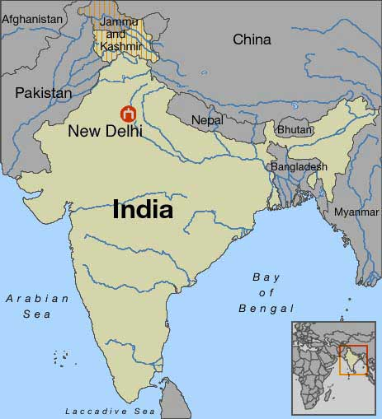  - Pryce’s (1979) work supports the idea that Pentecostalism acts to aid cultural transition by encouraging self reliance and thrift.  Their Culture of Origin:  - Ethnic minroties originate from poorer countries with traditional cultures, both of which produce higher levels of religiosity. On arrival to the UK, their children maintain the pattern they broguth with them. | - Secularisation suggests that religion is becoming less influential in people’s lives. Modood suggests that that religious observance decreases with every generation  - Rather than helping young ethnic minorities fit within society religion might be used as a rejection of the host society.
Age | - Not including children and the elderly, the older that people are the more likely they are to attend church  - The under 15s are more likely to go to church because they are taken by parents  - The over 65s are less likely to go to church because they are more likely to be ill or disabled | Ageing effect:  - Heelas (2005) argues that people become more religious as they get older. As people approach death they become naturally more concerned about where they are going. As a result people are more likely to attend church.  Generational effect  - Each new generation is less religious than the last. More older people go to church because religion was more popular when they grew up | - Secularisation suggests that religion is becoming less influential in people’s lives. Voas and Crockett suggests that that religious observance decreases with every generation  - Age has no impact for NRMs or some other religious movements. For example Pentecostalism have a very young membership
Conclusion:
- Postmodernists would argue that it is difficult to study one social group in isolation. Is an elderly Muslim woman religious because of her gender, ethnicity or age; rather a combination of all three.
- Postmodernists would also be critical of the definition of social groups. Modern definitions of gender and ethnicity have become outdated and therefore cannot be used in a description of religions relationship to social groups.

