Ethnicity, crime and justice
Introduction/key assumptions on ethnicity and criminalisation
- Blacks and to a lesser extent Asians are over-represented in official crime statistics given their proportion in the population.
- Self-report study data shows that whites, ‘mixed’ ethnic groups and blacks have similar rates of offending, with Asian groups being less likely to offend.
- Victim surveys show that blacks can be over-represented as offenders (e.g. in the case of mugging) and that offending is often intra-ethnic (within ethnic groups).
Ethnicity, racism and the criminal justice system | Explaining ethnic differences in offending |  | Ethnicity and victimisation
Policing and stop and search  - Black people make up 3% of the population, but 13.1% of the prison population.  - Asians make up 6.5% of the population, but 7.7% of the prison population.  - BCS data shows blacks are 8 times and Asians 2 times more likely to be stopped and searched by the police than whites.  - Asians are 3 times more likely to be stopped and searched under the Terrorism Act.  - Ethnic minority communities have a lack of trust in the police - they feel they are over-policed, under-protected and have limited faith in the police.  Reasons  1. Police racism  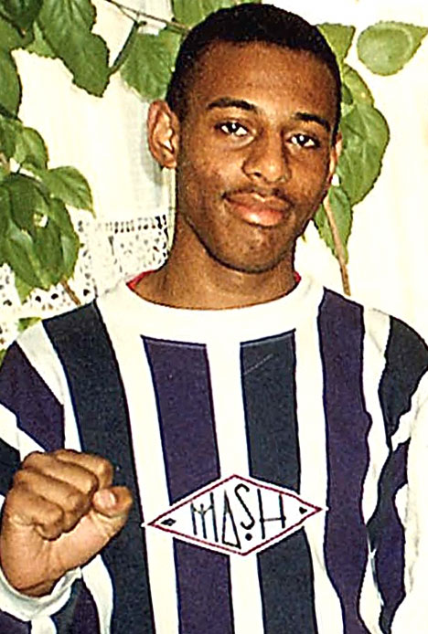  - The Macpherson Report (1999) found clear evidence of institutional racism in the Metropolitan Police.  - Phillips and Bowling (2007) found that many police officers stereotype ethnic minorities as criminals or dangerous terrorists leading to deliberate targeting/discrimination for stop and search.  2. Ethnic differences in offending  - Higher rates of stop and search reflect higher rates of offending amongst some ethnic minority groups (given their proportion in the population).  3. Demographic factors  - Some ethnic minority groups (e.g. blacks) are more likely to part of the demographic that is likely to be stopped and searched e.g. young, unemployed, living in inner city areas.  Arrests and cautions  - Blacks are 4 times more likely to be arrested than whites.  - Once arrested blacks and Asians are less likely to receive a caution.  Reason  - Minority groups may be less likely to admit to an offence (therefore not possible to be let off with a caution).  Prosecutions  - CPS is more likely to drop cases against ethnic minorities.  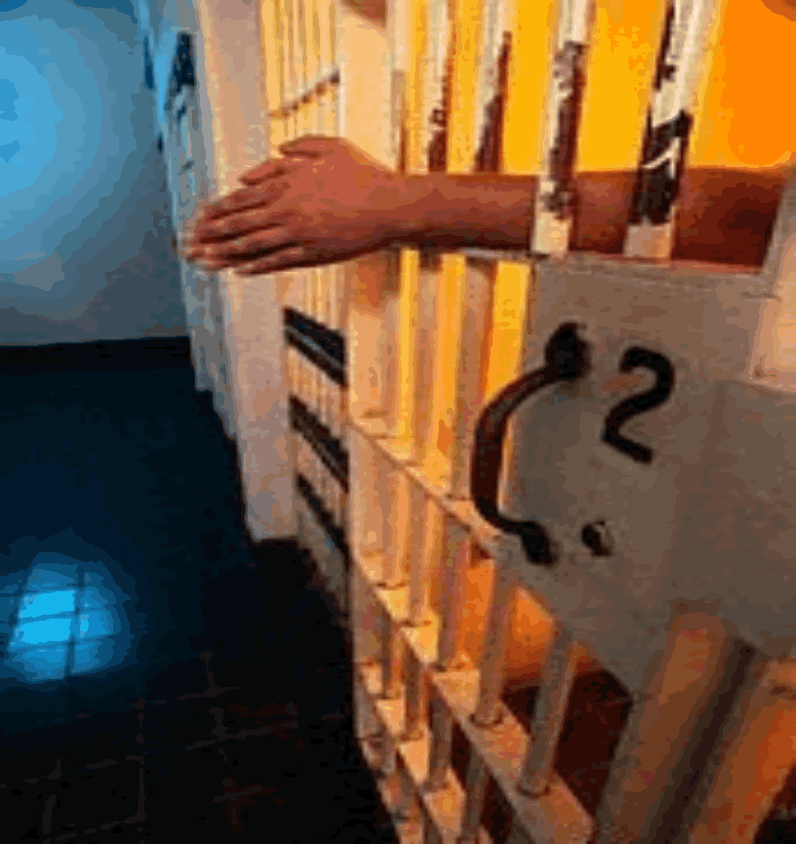  Reason  - Philips and Bowling (2002) argue this may be because the evidence presented to the CPS by the police is often weaker and based on stereotyping of wthnic minorities as criminals.  Convictions  - Blacks and Asians less likely to be found guilty.  Reason  - Discrimination – police/CPS bring in weak cases against ethnic minority groups.  Sentencing and prison  - Blacks more likely to receive a custodial sentence than whites or Asians (even when controlling for the serious of offence and previous convictions).  - Blacks are 5 times more likely to be in prison than whites.  - Black and Asian offenders more likely to be serving longer sentences.  Reason  - Ethnic minority groups are more likely to opt for a jury trial (as opposed to magistrates) where sentences are higher. | New (critical) criminology (Neo-Marxist) | Left realism | Extent and risk of victimisation  - The police recorded 54,000 racist incidents in England and Wales in 2014/15 (mainly damage to property or verbal harassment).  - The CSEW ESTIMATE 89,000 (i.e. most go unreported).  - OCS – 42,600 racially or religiously aggravated offences (mostly harassment).  - The police also recorded 38,000 racially or religiously aggravated offences in 2014-15, mostly harassment. 8,600 people were porsecuted or cautioned  - Mixed ethnic groups, blacks and Asians are more likely to be victims of a range of crimes than whites.  Reasons for racial incidents  - Racism and discrimination.  - ‘Relative deprivation downwards’ e.g. ‘hate crimes’ against asylum seekers (see LT6).  Reasons for differences for all crimes  - May reflect factors other than ethnicity e.g. violent crime is linked to being young, male, unemployed and living in inner city areas as much as ethnicity.  Effects of victimisation  - Psychological harm – a lot of racist victimisation is ongoing.  - Fear - BCS data shows that mixed ethnic groups, blacks and Asians fear crime more than whites. Whole communities can be affected by racially motivated hate crimes.  - Lack of faith – ethnic minority groups have little belief that the criminal justice system will deal effectively with racially motivated crime.  Responses to victimisation  - Under-protection from the police – the police often ignore, fail to record, or investigate racist incidents adequately. E.g. as shown by the Macpherson Report into the death of Stephen Lawrence.  - Situational crime prevention - fireproof doors and letterboxes, self-defence campaigns.  Limitations of victim surveys  See LT2.
 | Response to official crime statistics  - New criminologists largely reject official statistics, seeing them as a social construction (differences in the statistics are not real).  - Gilroy (1987) argues that black criminality is a myth created by racist stereotypes. He argues that powerless ethnic minority groups are over-represented in crime statistics because of police bias (over-policed).  - However, new criminologists do accept that ethnic minority crime and deviance needs to be explained in terms of causal processes as well. For example, Gilroy sees ethnic minority crime as form of political resistance against a racist society.  The causes and social construction of ethnic minority crime and deviance  - New criminologists such as Hall et al. (1979) have attempted to explain ‘black mugging’ (and the Toxteth riots) in terms of causes and social construction factors  - Wider causes – the marginalising effects of long term unemployment.  - Immediate causes - police racism in the case of riots.  - Social construction - moral panics. The focus on the panic of ‘black mugging’ drew attention away from the crisis of capitalism e.g. high unemployment and inflation and social problems such as student protests and the Northern Ireland crisis. Also served to divide the working class on racial grounds and justify increasing policing to suppress opposition.  - Social construction – stereotyping, selective law enforcement, self fulfilling prophecies and subcultural formation.  Evaluation of new criminology  Empirical evaluation  The new criminology has empirical support. BCS data shows that black males are 8 times more likely to be stopped and searched than white males. This suggests there is some validity in new criminology ideas.  Theoretical evaluation  Black feminism  Black feminists criticise the new criminology for failing to consider issues surrounding black women’s experience of crime.  For example, Player (1989) notes that black women are treated more harshly by the courts than white women. | Response to official crime statistics  - Left realists largely accept official crime statistics and therefore do not believe that powerless ethnic minority groups are significantly over-represented in them (they represent real differences in offending).  - They recognise that the statistics have problems in terms of police bias, but that this should not lead to complete rejection.  The causes of ethnic minority crime and deviance  Marginalisation  - Young (1997) argues in late modernity growing numbers of black (and some white and Asian) youths are finding themselves marginalised or economically/socially excluded because of racism, insecurity and family instability.  - For left realists this marginalisation is an underlying pressure for ethnic minority crime and deviance, but not in itself a direct cause.  Relative deprivation  - Young argues that crime is most likely to follow when individuals or groups feel relatively deprived.  - He maintains that some blacks (and some whites and Asians) often feel worse off than comparable groups and that these feelings of social injustice sometimes result in crime and deviance.  - Young argues that feelings of relative deprivation have increased in late modern society because expectations regarding consumption/cultural inclusion (e.g. ipods, latest mobiles etc.) have increased due to media pressures.  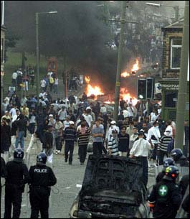  Subcultures  - Left realists claim that criminal and deviant subcultures emerge in all ethnic communities (but especially black) as a group response to marginalisation and relative deprivation.  - Subcultures allow groups of individuals to feel socially included and serve to facilitate crime and deviance by making such behaviour seem acceptable.  - Criminal subcultures may deal in drugs, and commit theft and robbery to close the ‘deprivation gap’. Conflict subcultures may engage in violence and rioting due to the frustrations of marginalisation.  Evaluation of left realism  Empirical evaluation  Left realist theories have gained empirical support. Jones et al.’s (1986) local Islington crime survey found that levels of victimisation and fear of crime were high, especially amongst black and Asian groups. This suggests there is some validity in the left realist ideas.  Theoretical evaluation  Right realism  - Right realists reject the left realist focus on social and economic causes of ethnic minority crime and concentrate instead on inadequate social control.  - For example, Murray (1990) sees the growth of the underclass as the key cause of black crime.  - He argues that the high proportion of black children from fatherless single parent families are inadequately socialised and controlled as they lack a male role model and authority figure.  - Murray believes some young black males turn to criminal role models on the street and gain status through crime rather than supporting their families through a steady job.
Conclusion for a question on differences in offending - left realism offers a strong theory as it recognises that ethnic minority crime can not be explained away as a social construction but requires causal explanation. However, all sociological theories, including left realism, need to look more closely at Asian crime and deviance. Unreported Britain (2002), suggest that crime and deviancy is growing in some Asian communities and locate the causes in terms of feelings of relative deprivation (as suggested by left realism) boredom, loss of respect for religion and changes in cultural identity.

