

Instructions

Ingredients

Must Have Aim For

Introduction

Conclusion

___ paragraphs

_______words

Each paragraph must have:

•Meat: the central idea: what paragraph is "about"

•Garnish: a range of concepts that complement the

central idea through illustrations, explanations,

application and evaluations.

•Sauce: examples of writers / studies that connect

the meat and the garnish.

For each paragraph you must use:

• at least one idea from the "meat" ingredients

• any number of ideas drawn from the "garnish"

ingredients.

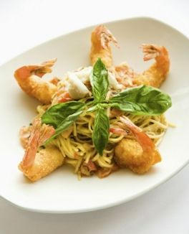• at least one idea drawn

from the list of sauces.

You can apply any of the

concepts in the "stock"

section to your answer as

and when required.

Notes



Sauces

Stock

Garnish

Meat

